MetaITEM NUMBER: CM-01979
REV: | DESCRIPTION: | ECO: | DATE: | APPROVED:
0.1 | SENT TO CUSTOMER FOR REVIEW |  | 09/09/2024 | J. PARKER
0.2 | DESIGN REWORK SENT TO CUSTOMER FOR REVIEW |  | 12/13/2024 | J. PARKER
0.3 | REGISTER AND COMMAND UPDATES |  | 06/01/2025 | J. PARKER
0.4 | BOOT MODE, FDIR DETAILS, REGISTER UPDATES AND COMMAND UPDATES |  | 06/17/2025 | J. PARKER
0.5 | MINOR REGISTER UPDATES INCLUDING ADDITION OF IP and MAC REGISTERS FOR CONFIGURING THE SECOND ETHERNET AS WELL AS A PROASIC3 FIRMWARE VERSION REGISTER |  | 7/15/2025 | J. PARKER
0.6 | SIMPLIFIED TMTC AND REMOVAL OF EVENTS FOR INITIAL RELEASE

TABLE OF CONTENTS
1.0 INTRODUCTION 3
1.1 PURPOSE 4
1.2 SCOPE 4
1.3 USAGE 4
1.4 CONTROL AUTHORITY 4
2.0 APPLICABLE DOCUMENTS 4
2.1 GOVERNMENT DOCUMENTATION 4
2.2 INTERNAL DOCUMENTATION 4
3.0 FARSIGHT SYSTEM OVERVIEW 5
3.1 TURION MISSION AND COMPANY AND COMPANY PROFILE 5
3.2 FARSIGHT COMPLIANCE 5
4.0 OPERATION & ARCHITECTURE 5
4.1 SYSTEM MODES 7
4.1.1 BOOT MODE (BOOT_MODE) 10
4.1.2 Low-Power Mode (LP_MODE – 0x00) 11
4.1.3 Update Mode (UPDATE_MODE - 0x01) 12
4.1.4 Idle Mode (IDLE_MODE – 0x02) 13
4.1.5 Manual Imaging Mode (MANUAL_MODE – 0x03) 14
4.1.6 Streaming Mode (STREAM_MODE – 0x04) 16
4.2 IMAGING OPERATIONS 17
4.2.1 SETUP AND CONFIGURATION 17
4.2.2 TRIGGERING OF IMAGE ACQUISITION 18
4.2.3 TIME SYNCHRONIZATION 18
4.2.4 Resets & Watchdogs 19
4.2.5 Latchup & Boot Failure Response 19
5.0 SOFTWARE TMTC INTERFACE 20
5.1 SERIAL INTERFACE 21
5.2 TMTC PACKET FORMAT 21
5.2.1 PKT_HDR 22
5.2.2 PKT_DATA 23
5.2.3 TL DATAGRAM FORMAT 23
5.3 FARSIGHT COMMANDS 24
5.3.1 Error Enumerations 25
5.3.2 Command Descriptions 26
5.3.2.1 GET_VERSION_SYS_CMD 27
5.3.2.2 SET_MODE_SYS_CMD 27
5.3.2.3 RESET_SYS_CMD 28
5.3.2.4 REG_READ_SYS_CMD 28
5.3.2.5 REG_WRITE_SYS_CMD 29
5.3.2.6 SET_TIME_SYS_CMD 29
5.3.2.7 START_ACQ_SYS_CMD 30
5.3.2.8 STOP_ACQ_SYS_CMD 30
5.3.2.9 FOCUS_SYS_CMD 30
5.3.2.10 HALT_FOCUS_SYS_CMD [Included in future releases] 31
5.3.2.11 XFER_BUFF_SYS_CMD 31
5.3.2.12 RESET_BUFF_SYS_CMD [Included in future releases] 32
5.3.2.13 GET_INFO_SYS_CMD [Included in future releases] 32
5.3.2.14 CONF_EVENT_LOG_SYS_CMD [Included in future releases] 33
5.3.2.15 EN_TL_CHAN_LOG_SYS_CMD [Included in future releases] 33
5.3.2.16 XFER_LOG_SYS_CMD [Included in future releases] 34
5.4 FARSIGHT REGISTERS 34
5.4.1 CAMERA STATUS AND CONTROL REGISTERS 35
5.4.2 SYSTEM REGISTERS 35
5.4.3 SYSTEM IMAGING REGISTERS 35
5.4.4 SYSTEM COMMUNICATION REGISTERS 36
5.4.5 SYSTEM VERSION REGISTERS 36
5.5 EXTENDED SYSTEM REGISTERS 36
5.6 REGISTER DESCRIPTIONS 37
5.6.1 SENSOR_STAT_SYS_REG 37
5.6.2 SENSOR_FRM_MOD_SYS_REG 37
5.6.3 SENSOR_BIT_DEPTH_SYS_REG 38
5.6.4 SENSOR_GAIN_SYS_REG 38
5.6.5 SENSOR_BLO_SYS_REG 38
5.6.6 SENSOR_EXPO_USEC_SYS_REG 38
5.6.7 SENSOR_TEMP_KEL_SYS_REG 39
5.6.8 SENSOR_OVER_TEMP_KEL_SYS_REG 39
5.6.9 MODE_SYS_REG 39
5.6.10 LAST_ERROR_SYS_REG 40
5.6.11 RST_REASON_SYS_REG 40
5.6.12 FPGA_TEMP_KEL_SYS_REG 40
5.6.13 FPGA_VOLTAGE_SYS_REG 40
5.6.14 DDR4_16_PWR_STATUS 41
5.6.15 DDR4_8_PWR_STATUS 41
5.6.16 LVDS_PWR_STATUS 41
5.6.17 ETH_1_PWR_STATUS 41
5.6.18 ETH_2_PWR_STATUS 41
5.6.19 FOCUS_MECH_PWR_STATUS 41
5.6.20 SENSOR_PWR_STATUS 41
5.6.21 ERROR_COUNT_SYS_REG 41
5.6.22 BOOT_COUNT_SYS_REG 41
5.6.23 UPTIME_MSEC_SYS_REG 42
5.6.24 TIMESTAMP_UNIX_SYS_REG 42
5.6.25 WDOG_TIMEOUT_MSEC_SYS_REG 42
5.6.26 BUFF_WRITE_POLICY_SYS_REG 42
5.6.27 BUFF_WRITE_PTR_SYS_REG 43
5.6.28 BUFF_BYTES_AVAIL_SYS_REG 43
5.6.29 FRAME_BYTE_PACKING_EN_REG 43
5.6.30 TRIG_MODE_SYS_REG 44
5.6.31 IMG_PER_TRIGGER_SYS_REG 45
5.6.32 FRAMES_PER_SEC_SYS_REG 46
5.6.33 CAP_START_DLY_USEC_SYS_REG 46
5.6.34 FRAME_COUNT_SYS_REG 46
5.6.35 FOCUS_REQ_DIST_M_SYS_REG 46
5.6.36 FOCUS_COMP_DIST_M_SYS_REG 47
5.6.37 FOCUS_LVDT_POS_NM_REG 47
5.6.38 GPO_CONF_SYS_REG 47
5.6.39 GPI_CONF_SYS_REG 47
5.6.40 INTR_PIN_CONF_SYS_REG 48
5.6.41 TRIG_PIN_CONF_SYS_REG 48
5.6.42 TRIG_DELAY_USEC_SYS_REG 49
5.6.43 TRIG_TIMEOUT_MSEC_SYS_REG 49
5.6.44 TMTC_TIMEOUT_MSEC_SYS_REG 49
5.6.45 SER_BAUD_SYS_REG 49
5.6.46 MAC_ADDRESS_1_SYS_REG 50
5.6.47 MAC_ADDRESS_2_SYS_REG 50
5.6.48 IP_ADDRESS_1_SYS_REG 50
5.6.49 IP_ADDRESS_2_SYS_REG 50
5.6.50 GATEWAY_SYS_REG 50
5.6.51 SUBNET_MASK_SYS_REG 50
5.6.52 ETH_0_PORT_SYS_REG 50
5.6.53 ETH_1_PORT_SYS_REG 51
5.6.54 FAV_DEVICE_ID_SYS_REG 51
5.6.55 SENSOR_ID_SYS_REG 51
5.6.56 TMTC_VERS_SYS_REG 51
5.6.57 SW_VERS_SYS_REG 51
5.6.58 PF_FW_VERS_SYS_REG 51
5.6.59 P3_FW_VERS_SYS_REG 52
5.6.60 FW_MD5_SYS_REG 52
5.0 PCIe DATA TRANSFER 52
6.0 IMAGE FORMAT & METADATA 53
6.1 IMAGE FRAME FORMAT 53
6.2 IMAGE METADATA 53

LIST OF FIGURES
Figure 4-1: FARSIGHT Camera Operations 11
Figure 4-2: FARSIGHT Architecture Diagram 12
Figure 4-3: Mode Transition Diagram 13
Figure 4-4: LP_MODE - Finite State Machine (TBR) 17
Figure 4-: UPDATE_MODE-Finite State Machine (TBR) 18
Figure 4-: IDLE_MODE – Finite State Machine (TBR) 19
Figure 4-: MANUAL_MODE – Finite State Machine (TBR) 20
Figure 4-: STREAM_MODE – Finite State Machine (TBR) 21
Figure 5-1:TMTC Packet Format 26
Figure 5-2: TL Event, TL Channel & Raw Image Segment Datagram Formatting 28

LIST OF TABLES
Table 2-1: Applicable Government Documentation 8
Table 2-2: Applicable TURION Documentation 9
Table 4-1: Modes of Operation 12
Table 4-2 BOOT_MODE-Entrance & Exit Criteria (TBR) 15
Table 4-3: LP_MODE-Entrance & Exit Criteria (TBR) 16
Table 4-4: UPDATE_MODE - Entrance & Exit Criteria (TBR) 17
Table 4-5: IDLE_MODE-Entrance & Exit Criteria (TBR) 18
Table 4-6: MANUAL_MODE – Entrance & Exit Criteria (TBR) 19
Table 4-7: STREAM_MODE – Entrance & Exit Criteria (TBR) 20
Table 5-1: Software TMTC Interface Terminologies 24
Table 5-2: FARSIGHT’s Serial Debug and Backup TMTC Interface Quick Reference 24
Table 5-3: Packet Header Field Descriptions 26
Table 5-4: Telemetry (TL) Event Descriptions 28

LIST OF ACRONYMS/ABBREVIATIONS

ACRONYM/ABBREVIATION | DEFINITION
C&DH | Command and Data Handling
CDS | Correlated Double Sampling
CMOS | Complementary Metal-Oxide-Semiconductor
CONOPS | Concept of Operations
CSR | Control and Status Registers
DEDOO | Dedicated Input/Output
EC | Embedded Clock
ECO | Engineering Change Order
FAV | FARSIGHT Payload Avionic Computer
FC | Flight Computer
FD | Full Digital
FPGA | Field Programmable Gate Array
GEO | Geostationary Orbit
GMRWT | Global Master Read Wait Time
GMTWT | Global Master Transfer Wait Time
GPI | General Purpose Input
GPO | General Purpose Output
HAL | FAV Hardware Abstraction Layer Middleware
ICD | Interface Control Document
LEO | Low Earth Orbit
NVM | Non-Volatile Memory
OB | Optical Black
PC | Payload Computer
PCIESS | Embedded PCIe Controller Subsystem
PGA | Programmable Gain Amplifier
PPS | Pulse Per Second
PWR | Power
RoHS | Restriction of Hazardous Substances
SERDES | Serializer/De-serializer
SHS | Shutter Sweep Time
SLVS | Scalable Low-Voltage Signaling
SLVS-EC | Scalable Low-Voltage Signaling with Embedded Clock
TMTC | Telemetry and Telecommand

INTRODUCTION
This document defines the interface functions and configuration parameters of the FARSIGHT system as a standalone camera module.

PURPOSE
This document serves as an overview of the software interface for the FARSIGHT telescope. This Interface Control Document (ICD) is not a standalone document and must be used in conjunction with the documents listed in Section 2 to ensure successful payload operations.

SCOPE
This document is valid with respect to the FARSIGHT system as a standalone camera system.

USAGE
This document is to be used by users of the FARSIGHT payload for development of software to interface with and operate the FARSIGHT payload as a standalone camera.

CONTROL AUTHORITY
Upon release of version 1.0, this document is under the TURION quality control system and shall propose changes in accordance with the internal Engineering Change Order (ECO) process. Prior to version 1.0 this document is considered under a DRAFT status.

APPLICABLE DOCUMENTS
The following documents, both program and non-program, are identified within this document. Unless a version number is specified, the latest version of these documents is to be used.

GOVERNMENT DOCUMENTATION
Future revisions of FARSIGHT’s Software ICD will include modifications to ensure compliance with the Government Standards listing in Table 2.1: Applicable Government Documentation.

Table 2-1: Applicable Government Documentation
Identifier | Document Title
- | JCO, SSA, GUIDANCE, CORRECTIONS_JULY2019.pdf
- | NGA.STND.0067_1.0_MIDSI_2021-10-20.pdf
- | NATIONAL IMAGERY TRANSMISSION FORMAT 2.1: Motion Imagery Extension, version 1.3.2, 2021-10-20

INTERNAL DOCUMENTATION
The following TURION documents and authorized changes form a part of this document.

Table 2-2: Applicable TURION Documentation
Identifier | Document Title
CM-00945 | EXPORT CONTROL, GUIDELINES, DOCUMENT MARKING
CM-01980 | ICD, ELECTRICAL, FARSIGHT

SUPPLIER DOCUMENTATION

The following external supplier documents are referenced throughout the document.

SUPPLIER | Document Title
Microchip | Polarfire MPF500T Specification, 2022. PolarFire-FPGA-Datasheet-DS00003831
Microchip | VSC8541-02/VSC8451-05 Datasheet, 2023
Microchip | Coretse Handbook, 2024.
Microchip | DDR AXI4 Arbiter User Guide, 2024.
Microchip | PolarFire FPGA SLVS-EC User Guide, 2024.
Microchip | SPI-DIRECTC User Guide, 2022.
Sony | IMX531-AAMJ-C Camera Specification, 2022. E20521D2Z.

FARSIGHT SYSTEM OVERVIEW
FARSIGHT is an optical payload designed for mid- to long-range non-Earth Imaging (NEI), supporting 5-year missions in Low-Earth Orbit (LEO) and Geostationary Orbit (GEO). Within the context of this document and based on the current software interface design, FARSIGHT represents a standalone camera.

TURION MISSION AND COMPANY AND COMPANY PROFILE
TURION was founded to accelerate the commercialization of space while focusing on key technological risks toward advancement of the greater vision of a prosperous and stable space economy. To address these risks, TURION uses a hardware-first approach to rapidly develop and iterate on space vehicles using a capability-based architecture to reduce risk and accelerate design iteration timelines.

FARSIGHT COMPLIANCE
FARSIGHT must enable the completion of the DRMs set forth by the relevant spacecraft mission. The SW version flown on each spacecraft must be compliant with restrictions or capabilities set forth by the DRMs.

FARSIGHT CAMERA SENSOR
FARSIGHT uses a Sony IMX531 camera sensor for capturing non-earth images. The specification of the camera sensor is provided in this section.

IMX531 Camera Sensor Features
The IMX531-AAMJ-C is a diagonal 17.5 mm (Type 1.1) CMOS active pixel type solid-state image sensor with a square pixel array and 20.35 M effective pixels. This chip features a global shutter with variable charge-integration time.
- CMOS active pixel type dots
- Built-in timing adjustment circuit
- Horizontal and vertical driver
- Serial communication circuit
- Global shutter function
- Embedded clock frequency: 54 MHz
- Number of recommended recording pixels: 4504(H) X 4504(V), approx. 20.28 MP

Features supported in FARSIGHT Avionics Firmware:
- All-pixel scan mode
- 12-bit pixel width
- Max frame rate 64 fps for 8GB DDR4 and 70 fps for 16 GB DDR4 memory buffer
- Variable-exposure duration via controlled trigger pin
- Monitor output for exposure period via dedicated output pin
- I/O interface SLVSEC 8 lane output
- Data transfer rate at 4.752 Gbps
- Programmable Gain Amplifier:
  - 0 dB to 24 dB: Analog Gain (0.1 dB step)
  - 24.1 dB to 48 dB: 24 dB Anaolog Gain + Digital Gain: 0.1 dB to 24 dB (0.1 dB step)

IMX531 Camera Sensor Pixel Arrangement
The recommended recording pixels of the camera sensor is 4504 x 4504 = 20.28 MP. The details of the pixel array are show in FIGURES REF.
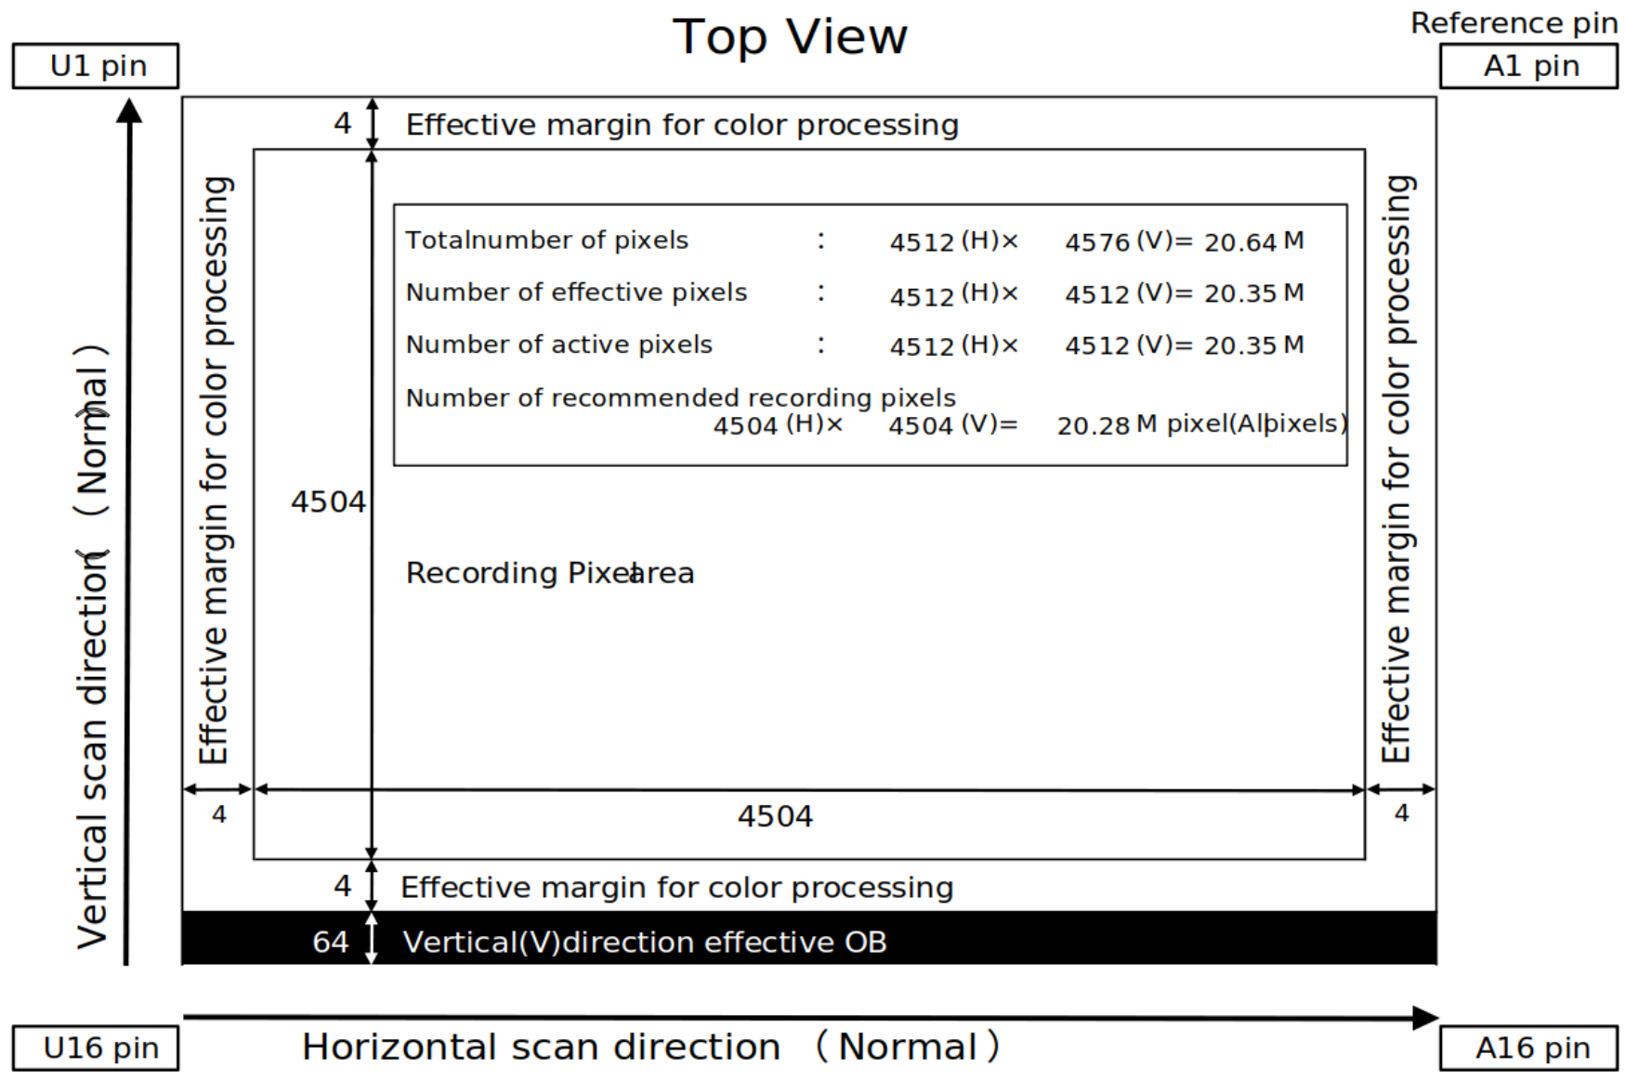

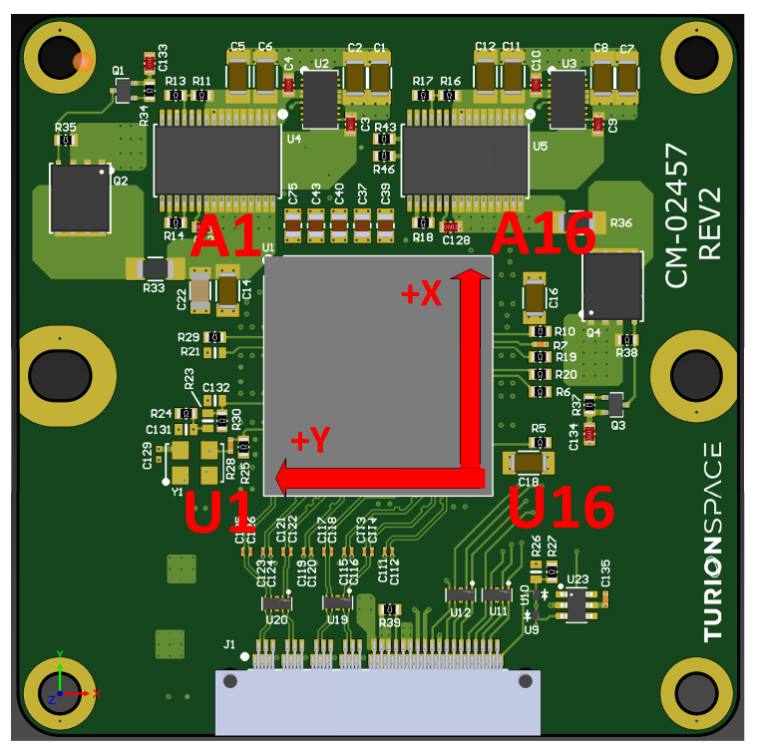

IMX531 Camera Sensor Readout Modes
The IMX531 image sensor supports four different readout modes. The readout modes are:
- All Pixel Scan
  - All pixels on the sensor are read without modification
- Vertical/Horizontal ½ subsampling
  - Pixels are sampled at ½ rate. Output image is 2252 x 2252.
- 2x2 FD binning
  - 2x2 grids of pixels and their respective photodiode are aggregated into one pixel. Output image is 2252 x 2252
- Region of Interest (ROI) and Overlapped ROI
  - Selective regions of the sensor can be chosen to be read. Image readout size depends on commanded ROI.

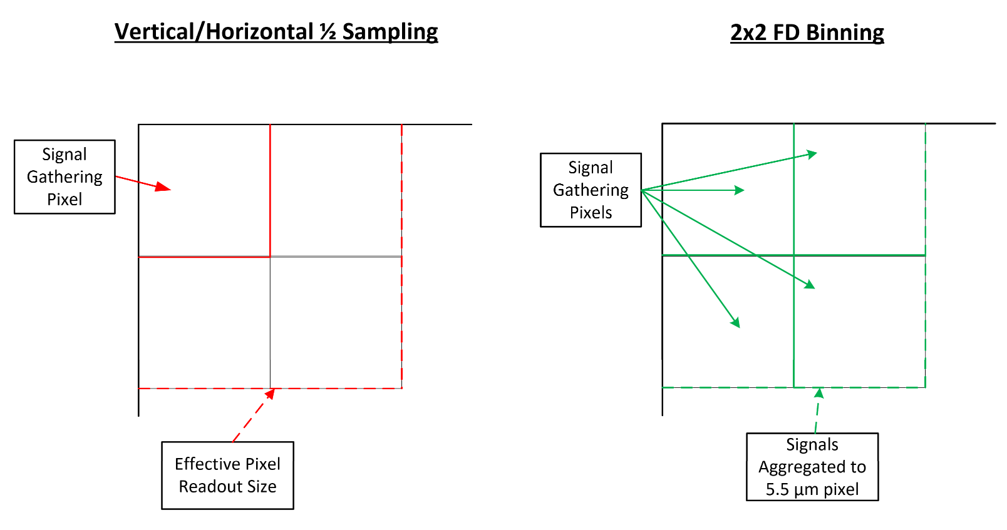
Readout modes are only valid during operation modes. Meaning there won’t be any reading during standby mode.
In the current version of FARSIGHT only the All-Pixel scan mode is supported.

FARSIGHT PACKED PIXEL STORAGE FORMAT
Figure XXX illustrates how pixels are stored in the DDR4 memory space. Pixels are stored in ascending order, starting at the lowest memory address of the DDR4. In the current design, pixels are always 12 bits wide and stored in a packed format; therefore, unpacking to 16 bits is required before further processing of the image.
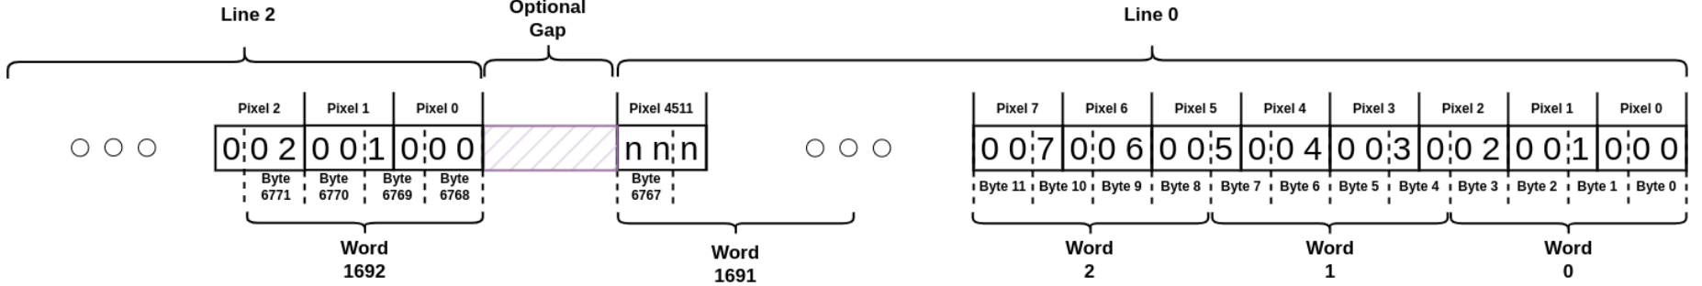
The first line of the frame always contains the metadata generated by the FPGA system at the moment of frame capture. Details of the metadata format are discussed in the subsequent sections. The next 64 lines of the frame constitute the Vertical Effective Optical Black (OB) region, which is used for calibration and dark current compensation. The actual image data begins at line 65 and spans a total of 4512 lines. after the 64 lines of VOB there is a 4 line of effective margine for color processing at the begining of the image and there is another 4 lines of effective margine for color processing at the end of the image. Each line of the frame consists of 4512 pixels, and since each pixel is 12 bits wide, the total size per line is 4512×12/8 = 6768 bytes.

FARSIGHT PACKED PIXEL UDP OUTPUT FORMAT
The FPGA transmits image frames via UDP packets to a host computer. Each frame consists of 4512×4576 pixels, where the image data begins at line 65 (after the 64-line Optical Black region and 1 metadata line).
FARSIGHT UDP Packet Structure:
Each UDP packet contains a 6-byte header followed by the pixel payload. Table XXX describes the packet header format.
Field | Size (bytes) | Description
Start Marker | 2 | Packet delimeter
Line Sequence | 2 | Line number within the frame (big-endian)
Packet Sequence | 2 | Packet number within the line (big-endian)
Payload | Variable | Packed 12-bit pixel data

Each line is transmitted across 5 UDP packets (packets 0-4), resulting in a total of 4576 X 5 = 22,880 packets per frame.
Camera Sensor Row Format:
Each row contains 4512 pixels in packed 12-bit format, yielding 4512 X 12 / 8 = 6768 bytes of pixel data. Additionally, each row includes 16 bytes of padding for memory alignment purposes, resulting in a total row size of 6788 + 16 = 6804 bytes.
The expected total frame size can be calculated as:
$$Frame Size=Height× \left(Packed Row Bytes+Padding\right)=4576×\left(6768+16\right)=31,039,484 bytes$$
Camera Sensor 12-bit Packed Pixel Unpacking Instruction
Pixels are stored in a packed format where every 12 bytes (96 bits) encode 8 pixels. The unpacking process interprets the data as three 32-bit big-endian words (W0, W1, W2) and extracts the 8 pixels using bitwise operations as shown in Table 47.
To convert 12-bit pixel values to 16-bit format for standard image processing applications, the pixel values are shifted left by 4 bits:
$$P_{16}=P_{12}≪4$$
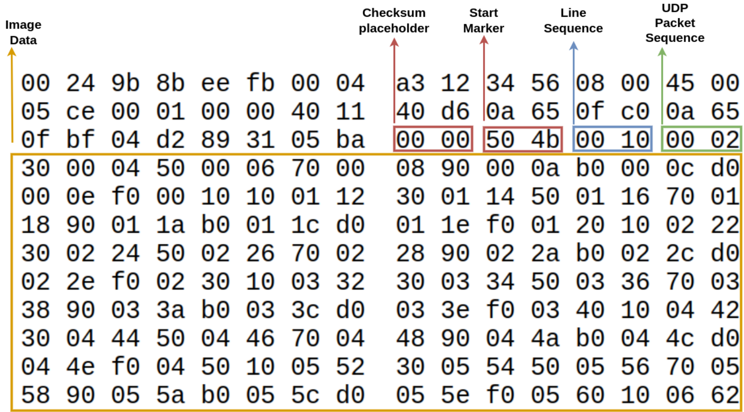
Pixel | Extraction Formula
$$P_{0}$$ | $$W_{0}∧0xFFF$$
$$P_{1}$$ | $$\left(W_{0}≫12\right)∧0xFFF$$
$$P_{2}$$ | $$\left(\left(W_{0}≫24\right)∨\left(W_{1}≪8\right)\right)∧0xFFF$$
$$P_{3}$$ | ($W_{1}≫4)∧0xFFF$
$$P_{4}$$ | $$\left(W_{1}≫16\right)∧0xFFF$$
$$P_{5}$$ | $${((W}_{1}≫28)∨(W_{2}≪4)) ∧0xFFF$$
$$P_{6}$$ | $$\left(W_{2}≫8\right)∧0xFFF$$
$$P_{7}$$ | $$\left(W_{2}≫20\right)∧0xFFF$$

Payload Computer Receiver Configuration Requirements:
To reliably receive high-bandwidth UDP image data without packet loss, the host system must be configured with adequate UDP receive buffer sizes. The recommended minimum buffer size is 256 MB. On Linux systems, this can be configured using:
sudo sysctl -w net.core.rmem_max=268435456
sudo sysctl -w net.core.rmem_default=268435456
To make these changes persistent across reboots, add the following lines to /etc/sysctl.conf:
net.core.rmem_max = 268435456
net.core.rmem_default = 268435456
FARSIGHT UDP Packet Loss Handling:
Due to the nature of UDP transmission, packets may occasionally be lost or arrive out of order. The receiver software implements the following strategies to handle these scenarios:
- Packet Reordering: Packets are buffered and writte in the correct sequence based on line and packet sequence numbers.
- Timeout Mechanism: If a packet does not arrive within a configurable wait time (default: 10 ms), the missing data is filled with zeros.
- Frame Timeout: If a complete frame is not received within the frame timeout period (default: 2 seconds), the frame is finalized with any missing packets filles with zeros

FARSIGHT HARDWARE ARCHITECTURE

FARSIGHT PHYSICAL INTERFACES
Figure Ref shows the physical interfaces of the FARSIGHT Payload system.
The FARSIGHT system connects to or includes the following components:
- Xiphos Q8JS Payload Computer (External Components):
  - RS422: Primary TMTC (Telemetry and Telecommand) serial interface.
  - 1GigE (x2): Dual Gigabit Ethernet connections for backup and primary data transfer.
  - PCIE x2 Gen2: High-speed PCIe interface for primary data transfer.
  - SPI: Used fo reflash operations.
  - PPS: Pulse Per Second timing signal source.
  - GPIOs (4x): External trigger input (EXT_TRIG), interrupt output (INTR), and general-purpose I/O signals.
- ProASIC3 FPGA: Handles power sequencing and system monitoring
- PolarFire FPGA (MPF500TS-FC1152M): The main processing unit that interfaces with the NVM and DDR4
  - 64 Mb Microchip RT NVM: Non-volatile memory connected via QSPI for configuration storage.
  - Micron DDR4 (24 GB): Frame buffer memory (18x MT40A2G7AG-062E AUT:F) for image storage.
- Sony IMX531-AAMJ-C Sensor: Connected to the PolarFire FPGA
  - 8-Lane SLVS-EC: High-speed data interface running at 4.752 Gbps/lane
  - SPI: Sensor control interface
  - XTRG1: Exposure trigger GPIO
  - XCLR: Settings clear GPIO
  - TOUT0: Exposure timing knowledge GPIO.
- FARSIGHT Optical Assembly: Includes 13x thermistors for temperature monitoring and 7x heaters for thermal control.
- Focus Mechanism: Controlled by the PolarFire FPGA with LVDT feedback for position sensing.
- Heater and Thermistor: Additional thermal management components with direct connection to electrical interface.

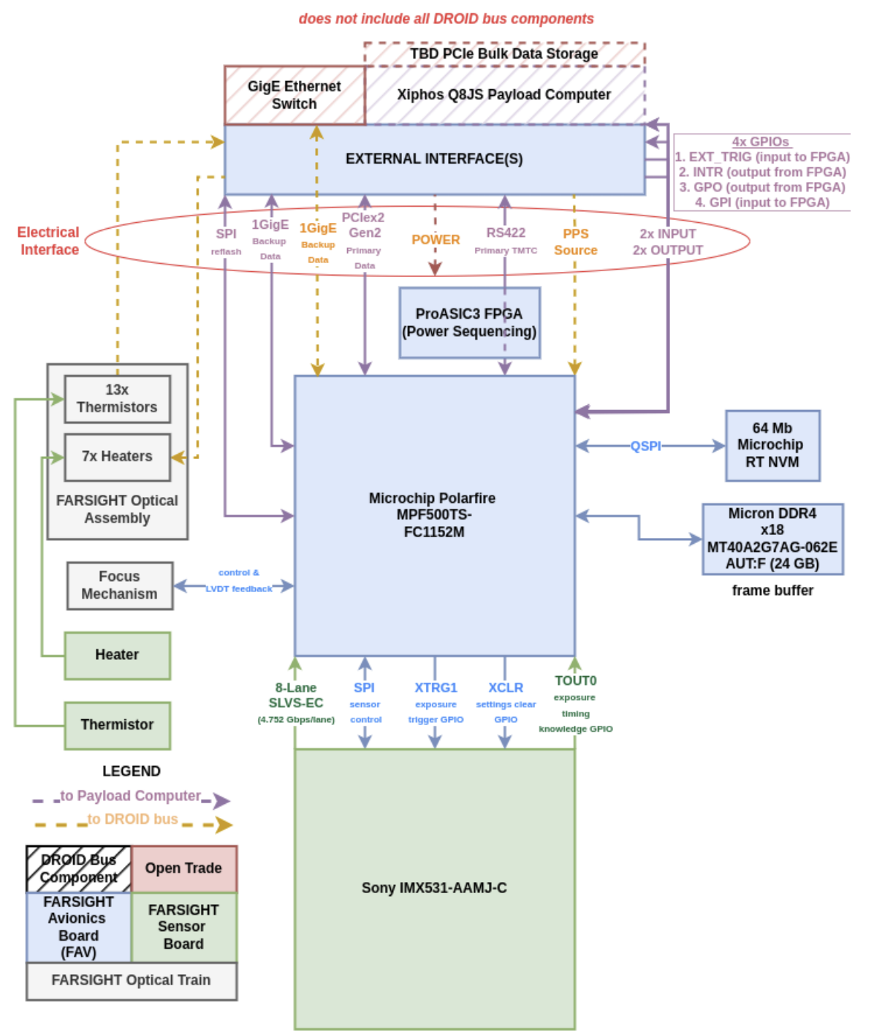

OPERATION & ARCHITECTURE
Figure 4-1 is a high-level flow diagram that provides an example of how FARSIGHT is expected to be operated as a standalone camera module. The rest of this document details modes, commands and telemetry values used to enable this outlined operation.
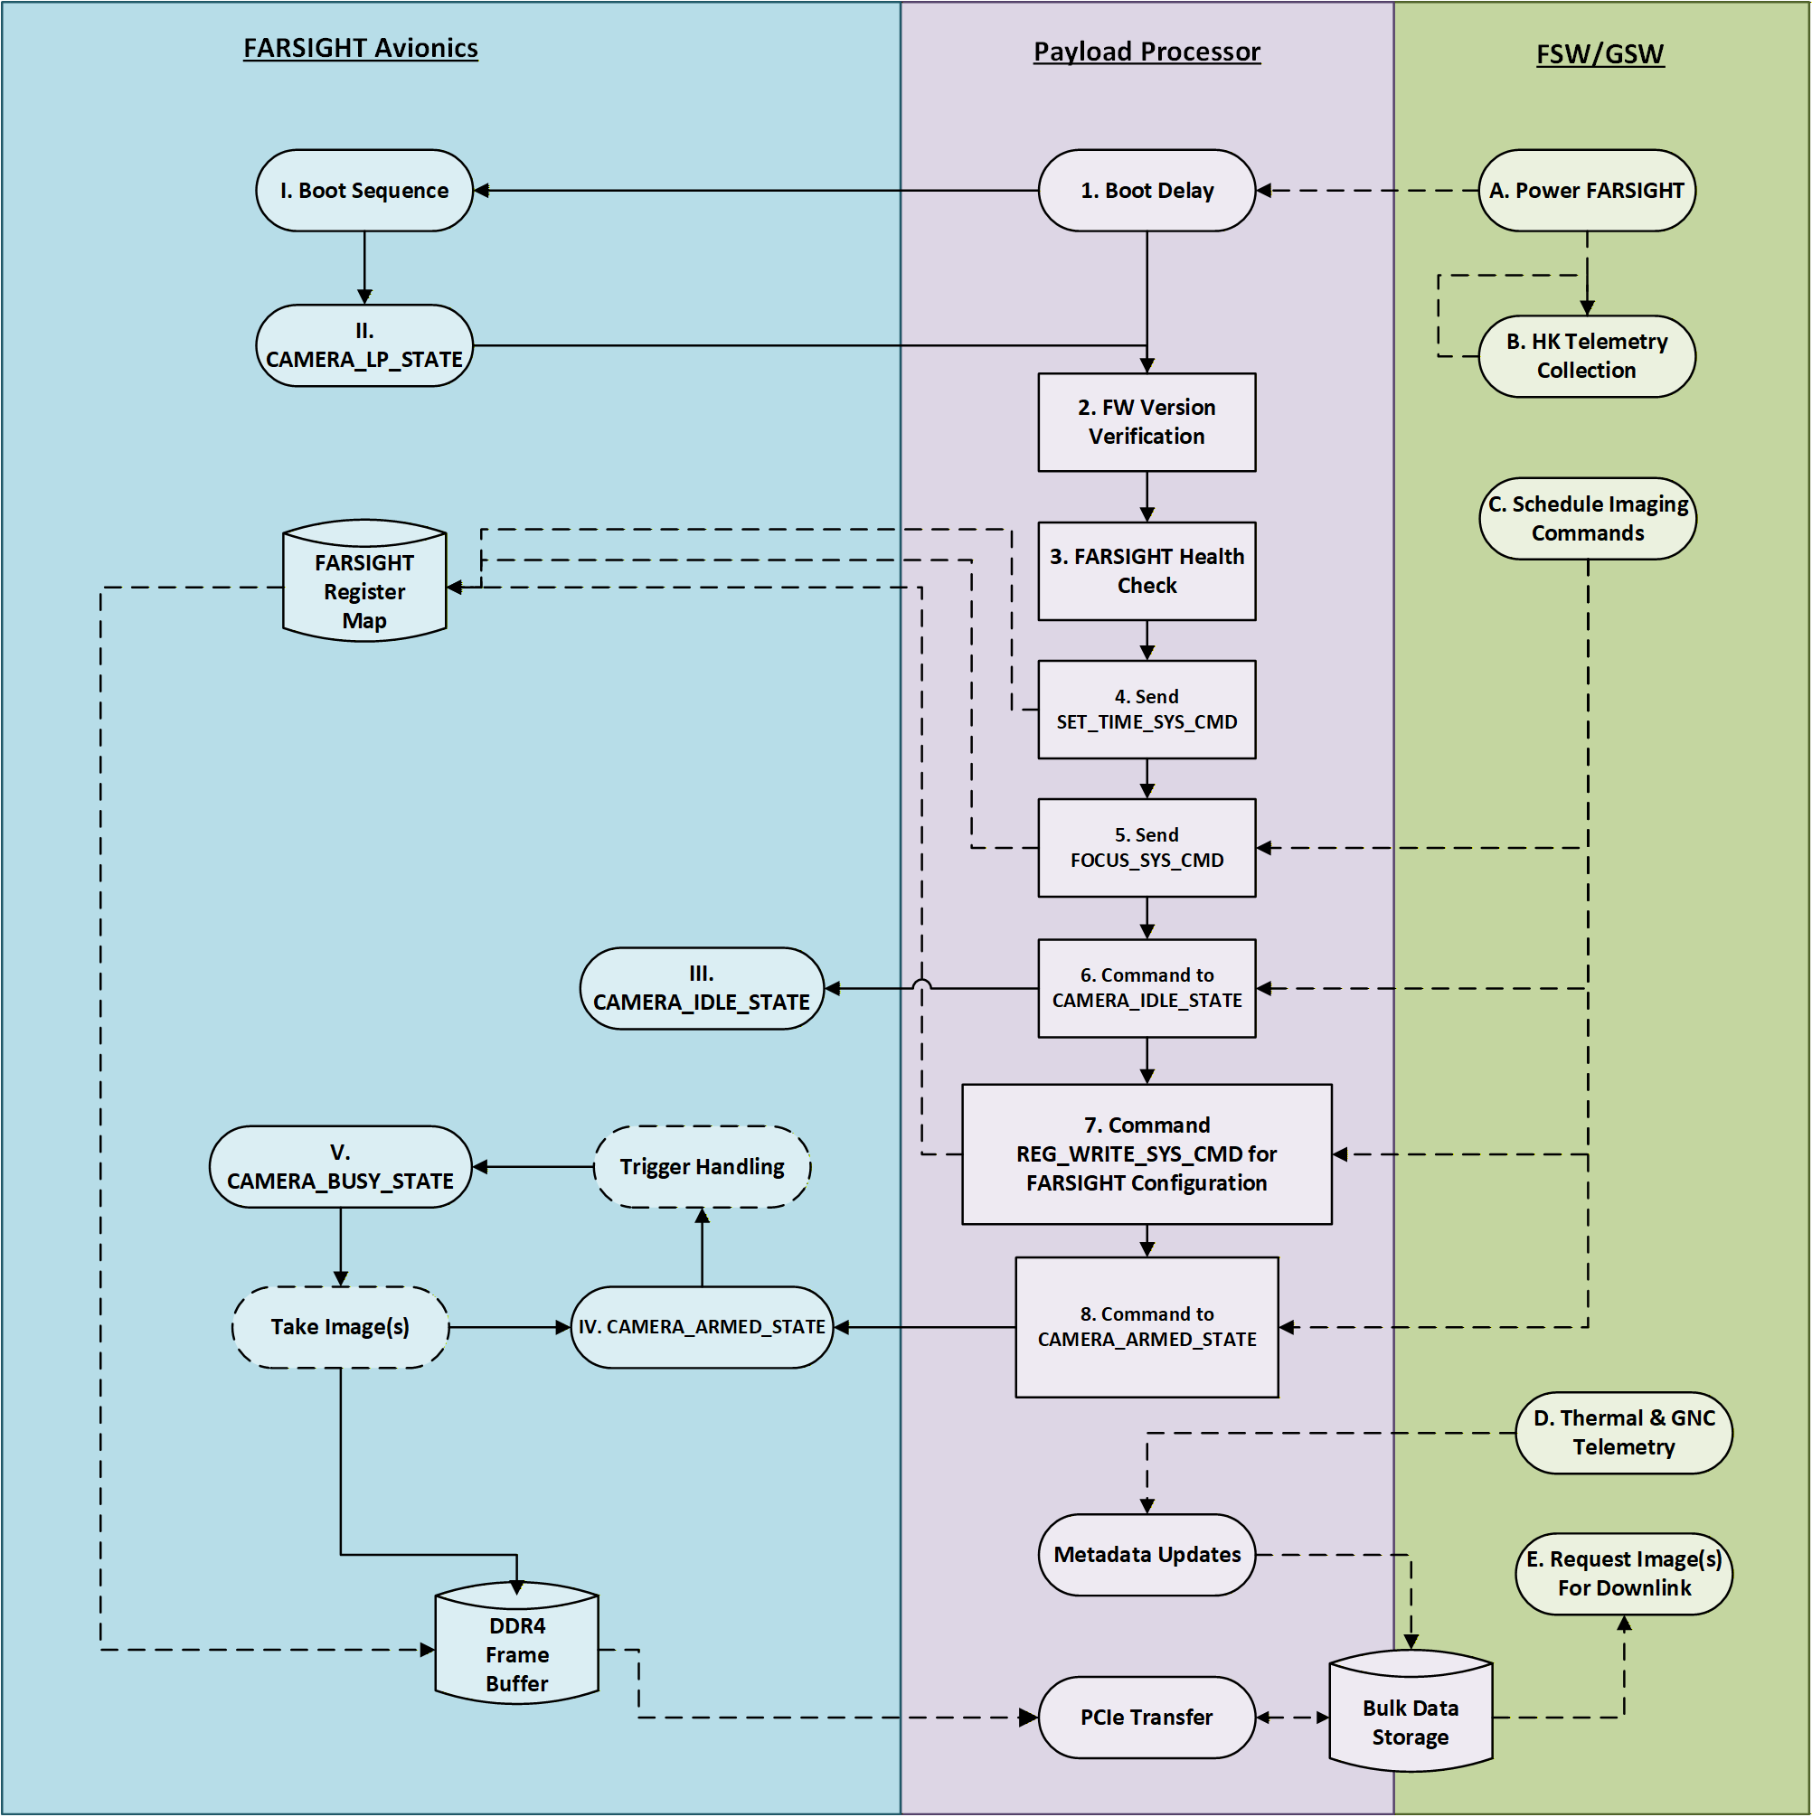
Figure 4-1: FARSIGHT Camera Operations

SYSTEM MODES
This section provides an overview of FARSIGHT’s five modes of operation. A high-level overview of these modes are pro
d in Table 4-1 below, with individual modes further detailed in this section. For details on mode transition commands, see the respective detailed sections for each mode.

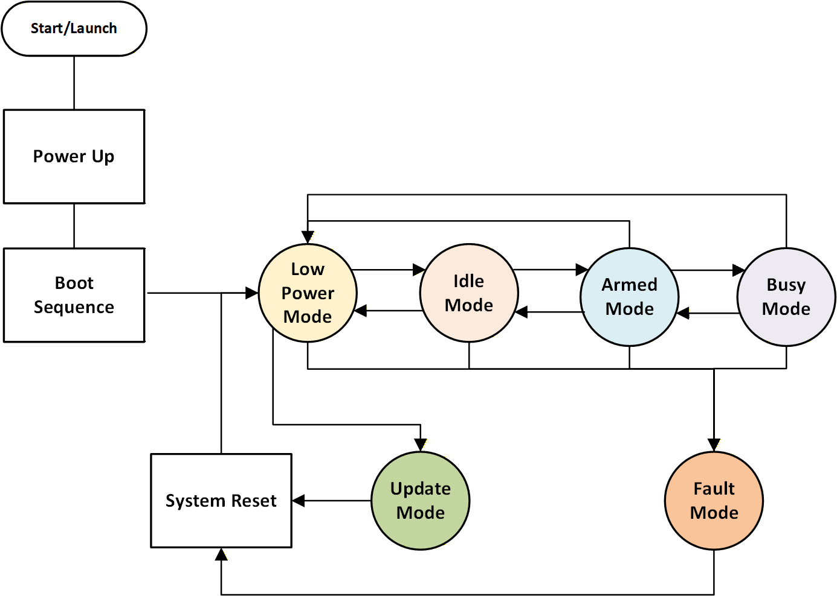
Figure 4-3: Mode Transition Diagram

Table 4-1: Modes of Operation
Mode | Description
Low Power (CAMERA_LP_STATE) | The default mode after a reset and successful boot of critical power regions. FARSIGHT can also be commanded to enter this mode. Within this mode, the camera sensor is not powered, health telemetry acquisition begins, and FARSIGHT awaits a command for mode transition. From Low Power State, FARSIGHT can be commanded to enter Idle State.
Update | Upon request, FARSIGHT will transition from Low Power Mode to Update Mode to facilitate updates of FARSIGHT’s FPGA (Field Programmable Gate Array) Firmware, RISC-V (Reduced Instruction Set Computer) software and TMTC protocol from the controlling host. While in this mode the CMOS sensor is powered off and all FPGA activity is halted other than what is required during the firmware update process. From Update Mode, FARSIGHT will automatically perform a reset or require a power cycle (To Be Refined) to then transition back into Low Power Mode.
Idle (CAMERA_IDLE_STATE) | Upon request, FARSIGHT will transition from Low Power State to Idle State, where FARSIGHT will prepare for image acquisition commands and nominal payload operations. When FARSIGHT enters this state, the CMOS sensor and all required interfaces for imaging operations will be enabled to prepare for imaging commands. From Idle State, FARSIGHT can transition to Armed State or return to Low Power State.
Armed (CAMERA_ARMED_STATE) | A preparatory state where the system is configured and awaiting a capture trigger. The imaging subsystem is primed and ready for immediate operation. In this state, FARSIGHT awaits either a user-initiated cue or a scheduled capture event to begin image acquisition. From Armed State, FARSIGHT can transition to Busy State upon receiving a capture command, or return to Idle State via the disarm command.
Busy (CAMERA_BUSY_STATE) | Upon request, FARSIGHT will transition from Armed State to Busy State, where the system actively captures images and stores them into the designated DDR4 frame buffer space. Further details about the imaging operation are provided in the subsequent SDD. During imaging, certain camera sensor parameters can be updated via SPI commands; some updates will be applied immediately to the current frame, while others will take effect on the next frame. The specifics of parameter update timing are described in later sections. Upon completion of image capture, the FPGA hardware generates an interrupt to the RISC-V firmware indicating capture completion, at which point FARSIGHT transitions from Busy State back to Armed State.
Fault (CAMERA_FAULT_STATE) | A safety state entered when a housekeeping (HK) fault is detected. This state can be reached from Low Power, Idle, or Armed states when the system detects anomalous conditions that require immediate attention.

POWER UP & BOOT SEQUENCE
FARSIGHT is initiated by enabling the NPS channel on the host side. The FARSIGHT hardware is booted in sequence as dictated by Table Ref. Afterwards, FARSIGHT Avionics will check for an existing firmware image. The power region and their respective power sources will be booted one by one until the entire sequence has been successfully completed. The housekeeper FPGA will attempt to boot a respective power region up to 4 times before aborting the boot sequence.
Boot Order | Power Region | Power Sources | Has nfault? | Critical? | PolarFire SW Controlled? | Mode when Enabled | Nominal Boot Time
1 | Step Down Converters | 2v2 | Yes | Yes | No | Boot Sequence | 2.6ms
2 | Step Down Converters | 3V0 | Yes | Yes | No | Boot Sequence | 2ms
3 | Step Down Converters | 4V0 | Yes | Yes | No | Boot Sequence | 2ms
4 | DDR8 | 2V5 | Yes | No | No | Boot Sequence | 0.704ms
5 | DDR8 | 1V2 | Yes | No | No | Boot Sequence | 0.52ms
6 | DDR8 | 0V6 | No | No | No | Boot Sequence | 0.4ms
7 | DDR16 | 2V5 | Yes | No | No | Boot Sequence | 1.23ms
8 | DDR16 | 1V2 | Yes | No | No | Boot Sequence | 0.91ms
9 | DDR16 | 0V6 | No | No | No | Boot Sequence | 0.4ms
10 | FPGA | 1V0 | Yes | Yes | No | Boot Sequence | 0.64ms
11 | FPGA | 1V0A | No | Yes | No | Boot Sequence | 2.3ms
12 | FPGA | 1V25A | No | Yes | No | Boot Sequence | 2.3ms
13 | FPGA | 1V8 | No | Yes | No | Boot Sequence | 2.3ms
14 | FPGA | 1V8 IMX | No | Yes | No | Boot Sequence | 2.3ms
15 | FPGA | 2C5A | No | Yes | No | Boot Sequence | 2.3ms
16 | FPGA | 3V3 B4 | No | Yes | No | Boot Sequence | 2.3ms
17 | FPGA | 3V3 B5 | No | Yes | No | Boot Sequence | 2.3ms
1 | LVDS | 3V3 | No | No | Yes | Boot Sequence | 2.3ms
1 | Eth1 | 1V0 | No | No | Yes | Boot Sequence | 2.3ms
2 | Eth1 | 1V0A | No | No | Yes | Boot Sequence | 2.3ms
3 | Eth1 | 2V5A | No | No | Yes | Boot Sequence | 2.3ms
4 | Eth1 | 3V3 | No | No | Yes | Boot Sequence | 2.3ms
1 | Eth2 | 1V0 | No | No | Yes | Boot Sequence | 2.3ms
2 | Eth2 | 1V0A | No | No | Yes | Boot Sequence | 2.3ms
3 | Eth2 | 2V5A | No | No | Yes | Boot Sequence | 2.3ms
4 | Eth2 | 3V3 | No | No | Yes | Boot Sequence | 2.3ms
1 | Stepper Primary Motor | 28V0 | Yes | No | Yes | Only When In Use | N/A
1 | Stepper Secondary Motor | 28V0 | Yes | No | Yes | Only When In Use | N/A
1 | LVDT | 15V0 | No | No | Yes | Only When In Use | N/A
1 | IMX531 | 1V1 | Yes | No | Yes | CAMERA_LP_STATE | 1.22ms
2 | IMX531 | 1V8 | No | No | Yes | CAMERA_LP_STATE | 2.3ms
3 | IMX531 | 2V9 | No | No | Yes | CAMERA_LP_STATE | 0.45ms
4 | IMX531 | 3V3 | No | No | Yes | CAMERA_LP_STATE | 5.1ms

Criteria Description
Entrance Criteria | - NPS Channel for FARSIGHT is initially disabled  - FARSIGHT is not in any operational mode
Exit Criteria | - Critical hardware is successfully booted  - FPGA initialized

Low Power (CAMERA_LP_STATE)
As described in Table 4-1, CAMERA_LP_STATE is the default mode FARSIGHT will enter once critical components have successfully booted or commanded to enter this mode. CAMERA_LP_STATE’s entrance and exit criteria (see Table 4-2), FARSIGHT state description as well as the sequence of operations (see Figure 4-4) are described below.
After transitioning to CAMERA_LP_STATE, FARSIGHT initializes to a minimal state for communication with the host. After CAMERA_LP_STATE initialization completes, FARSIGHT will be in the state detailed in the list below:
- CMOS Sensor is disabled
- FPGA is powered on
- Pins initialized to default state
- FARSIGHT is collecting state-of-health telemetry
- FARSIGHT is listening for commands

Table 4-3: LP_MODE-Entrance & Exit Criteria (TBR)
Criteria Description
Entrance Criteria | - FARSIGHT was Reset through a valid RESET_SYS_CMD command  - Provided a valid SET_MODE_SYS_CMD command to CAMERA_LP_STATE = 0x00  - FPGA initializes properly  - Watchdog timer expires
Exit Criteria | - Imaging sensor temperature within operating temperature range  - Provided a valid SET_MODE_SYS_CMD command to either  - UPDATE_MODE = 0x01 – to initiate FARSIGHT’s update process  - IDLE_MODE = 0x02– to initialize the sensor and prepare for imaging operations

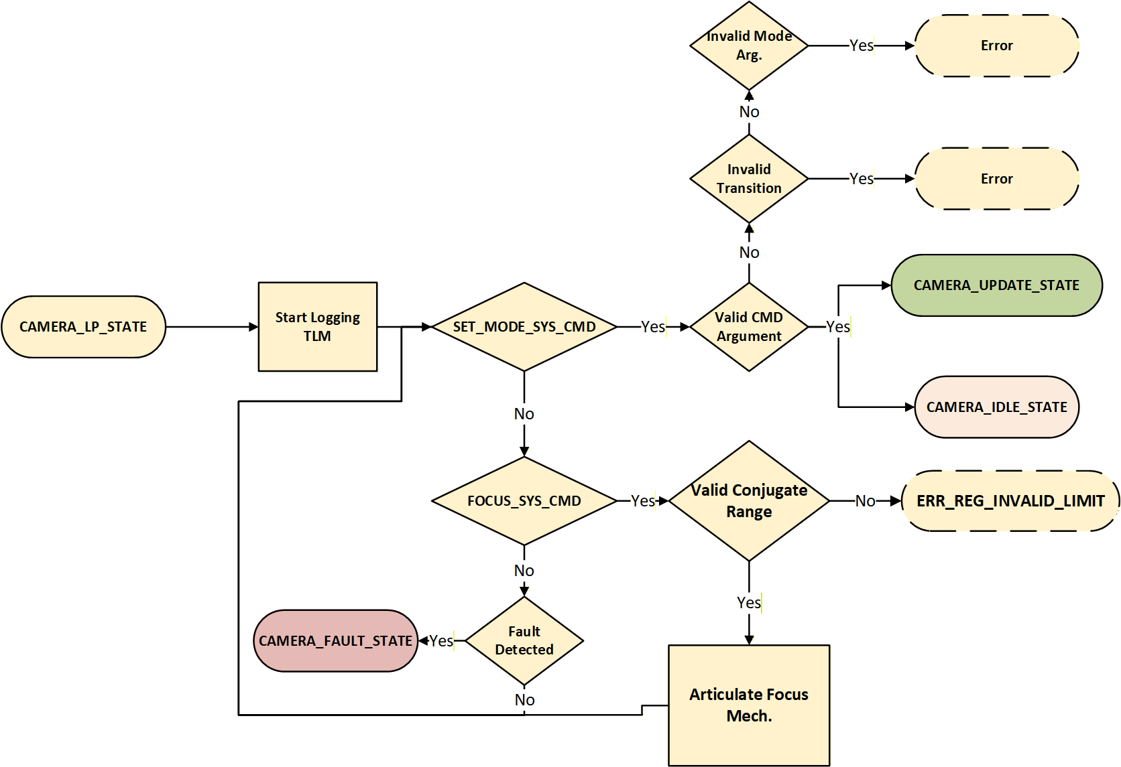

Update Mode (CAMERA_UPDATE_STATE):
As described in Table 4-1, FARSIGHT can be commanded to enter CAMERA_UPDATE_STATE to permit updates of firmware, software and TMTC protocol from the host. CAMERA_UPDATE_STATE’s entrance and exit criteria (see Table 4-3), FARSIGHT state description as well as the sequence of operations (see Figure 4-5) are described below.
After transitioning to CAMERA_UPDATE_STATE, FARSIGHT will disable all functionality other than that which is required to update the FPGA’s firmware. After the update process is completed, FARSIGHT will reset to then transition back to CAMERA_LP_STATE.
Table 4-4: UPDATE_MODE - Entrance & Exit Criteria (TBR)
 | Criteria Description
Entrance Criteria | - FARSIGHT is initially in CAMERA_LP_STATE and respective exit criteria is satisfied  - Provided a valid SET_MODE_SYS_CMD with Opcode = 0x01
Exit Criteria | - Host finishes transfer of firmware update  - Valid RESET_SYS_CMD has been received

To facilitate programming, the host should use Microchip’s DirectC SPI-Direct library and follow protocols as described.

Idle Mode (CAMERA_IDLE_STATE)
As described in Table 4-1, FARSIGHT can be commanded to enter CAMERA_IDLE_STATE to prepare for image acquisition operations. CAMERA_IDLE_STATE’s entrance and exit criteria (see Table 4-4) as well as the sequence of operations (see Figure 4-6) are described below.
Table 4-5: IDLE_MODE-Entrance & Exit Criteria (TBR)
 | Criteria Description
Entrance Criteria | One of the following:  - FARSIGHT is in CAMERA_LP_STATE and CAMERA_LP_STATE exit criteria satisfied and provided a valid SET_MODE_SYS_CMD command to IDLE_MODE = 0x02  - FARSIGHT is in CAMERA_ARMED_STATE and CAMERA_ARMED_STATE exit criteria satisfied and provided a valid SET_MODE_SYS_CMD commanded to CAMERA_ARMED_STATE = 0xXX
Exit Criteria | One of the following:  - CAMERA_LP_STATE entrance criteria satisfied and a valid SET_MODE_SYS_CMD is provided with argument CAMERA_LP_STATE = 0x00  - CAMERA_ARMED_MODE entrance criteria satisfied and a valid SET_MODE_SYS_CMD is provided with argument CAMERA_ARMED_STATE = 0x02

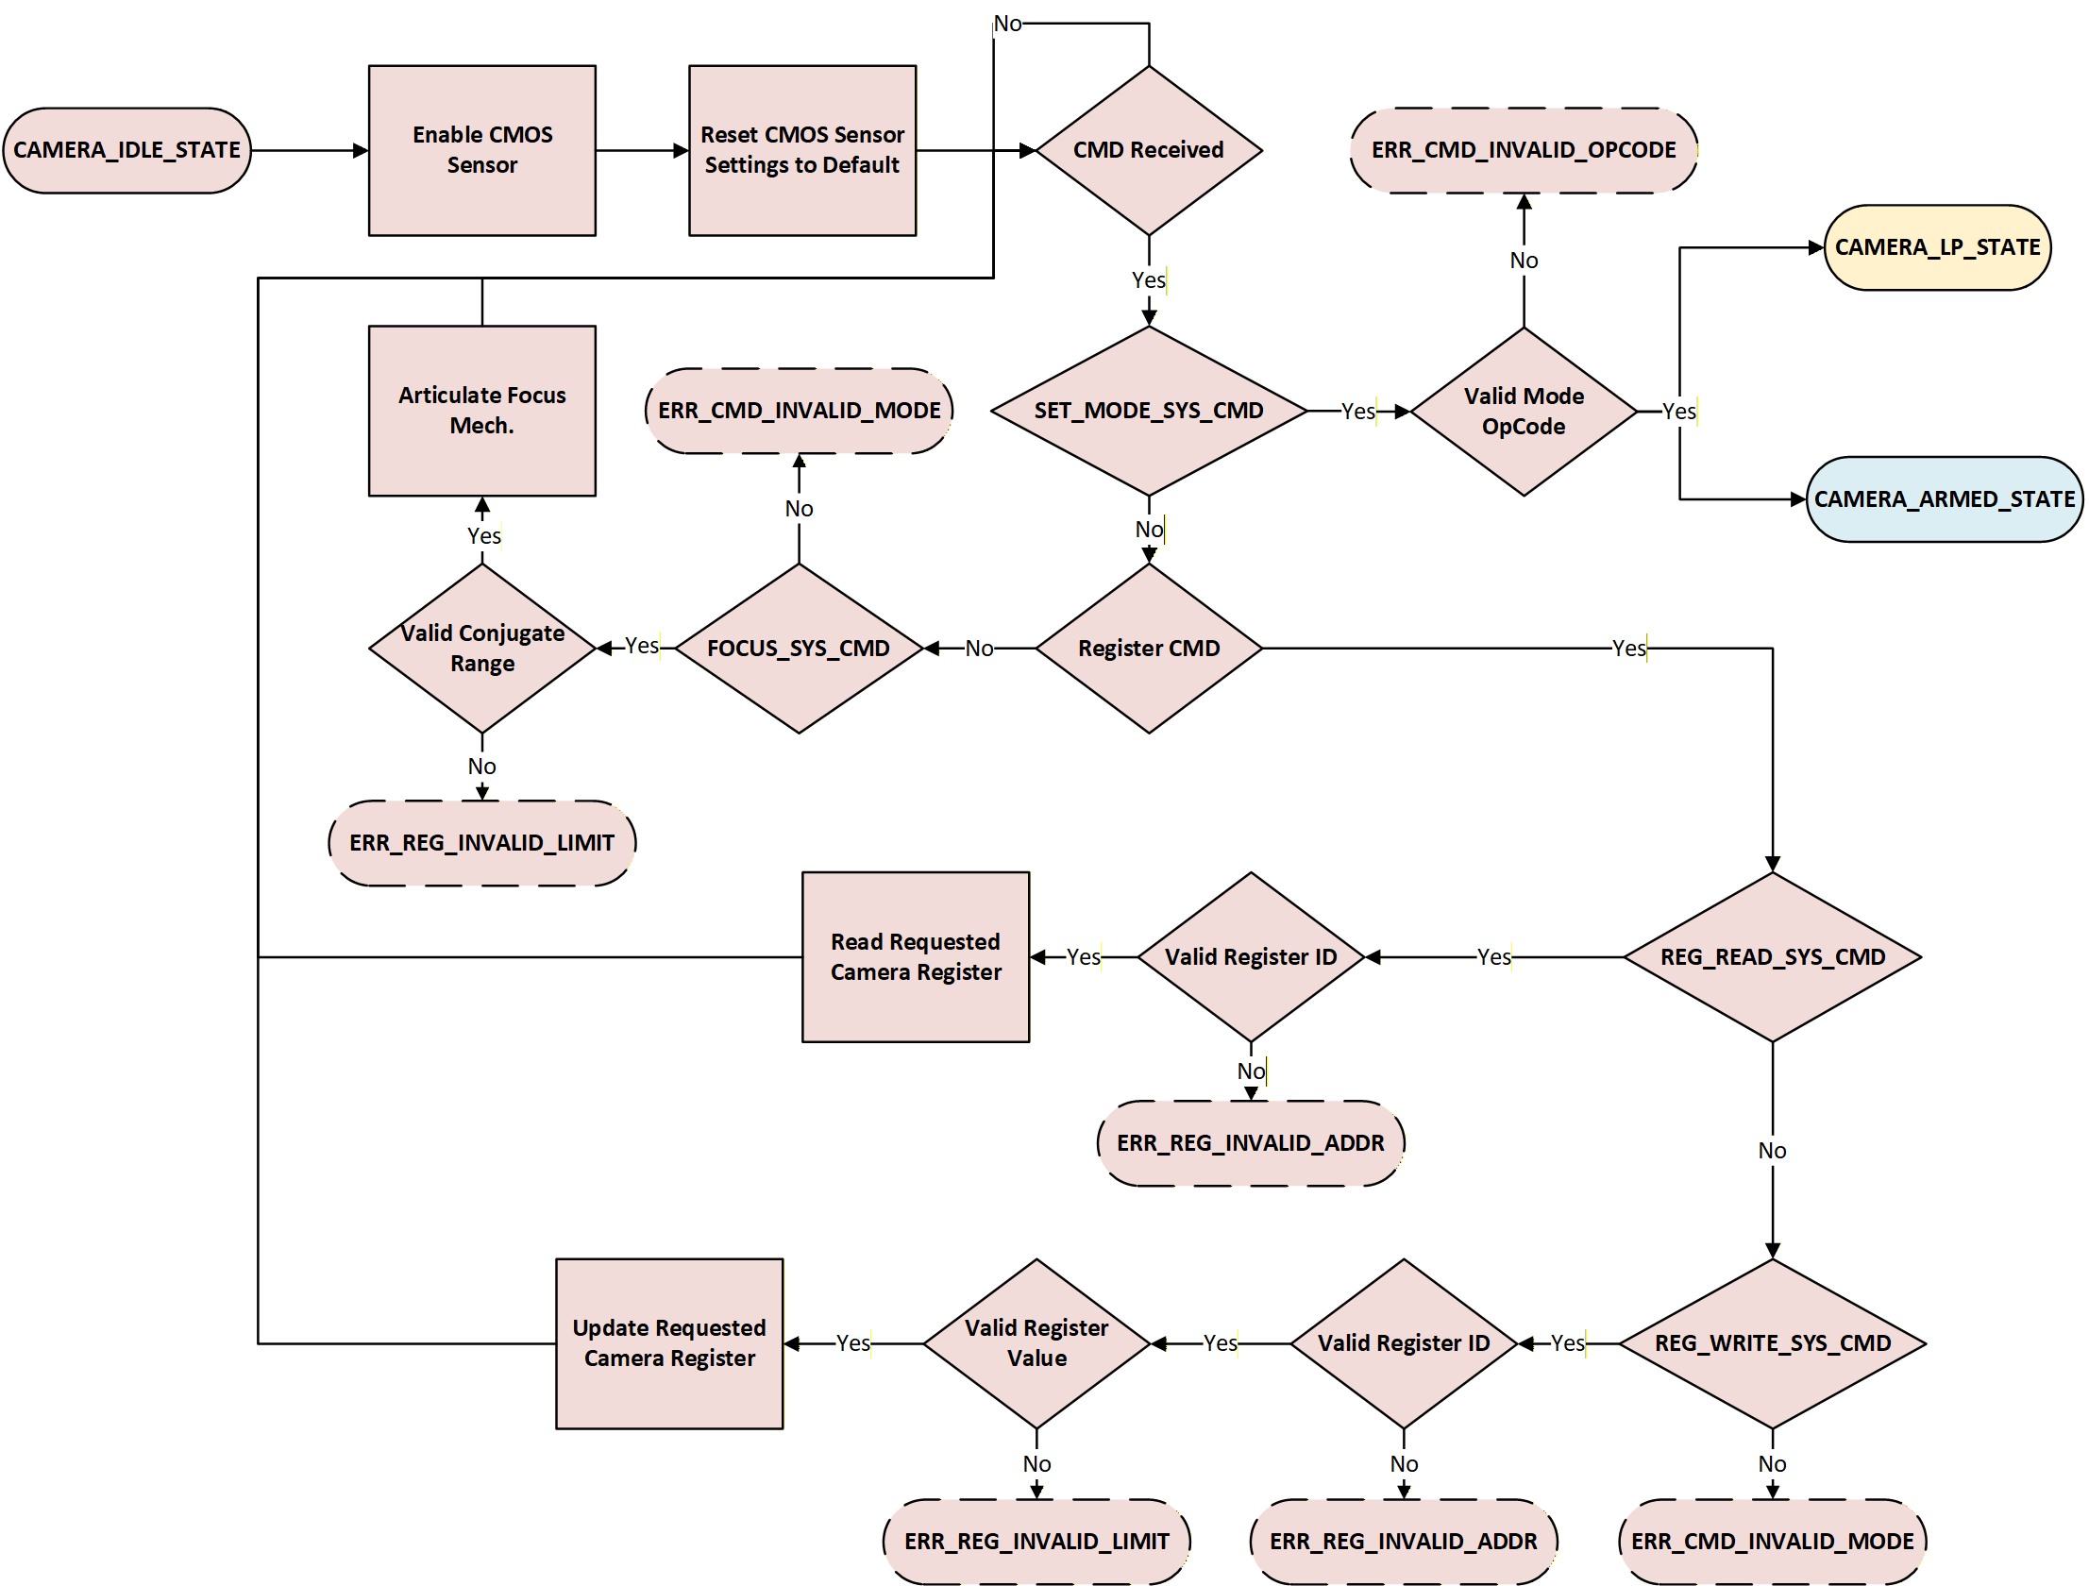

Armed Mode (CAMERA_ARMED_STATE)
Image acquisition starts with the initial switch to CAMERA_ARMED_STATE, where the sensor can be configured and will wait for the configured trigger to switch to CAMERA_BUSY_STATE. Registers used for imaging in CAMERA_BUSY_STATE are the registers that are set at the time of the trigger and will persist until the camera returns to CAMERA_ARMED_STATE.
Table 4-6: MANUAL_MODE – Entrance & Exit Criteria (TBR)
 | Criteria Description
Entrance Criteria | - FARSIGHT is in CAMERA_IDLE_STATE and exit criteria for CAMERA_IDLE_STATE have been satisfied with a valid SET_MODE_SYS_CMD with argument CAMERA_ARMED_STATE = 0x02  - FARSIGHT is in CAMERA_BUSY_STATE and exit criteria for CAMERA_BUSY_STATE have been satisfied
Exit Criteria | - CAMERA_LP_STATE entrance criteria satisfied and a valid SET_MODE_SYS_CMD is provided with argument CAMERA_LP_STATE = 0x00  - CAMERA_IDLE_STATE entrance criteria satisfied and a valid SET_MODE_SYS_CMD is provided with argument CAMERA_IDLE_STATE = 0x01  - The trigger conditions dictated by the set camera trigger in the SENSOR_TRIG_MODE_SYS_REG have been satisfied (see TABLE REF for details)

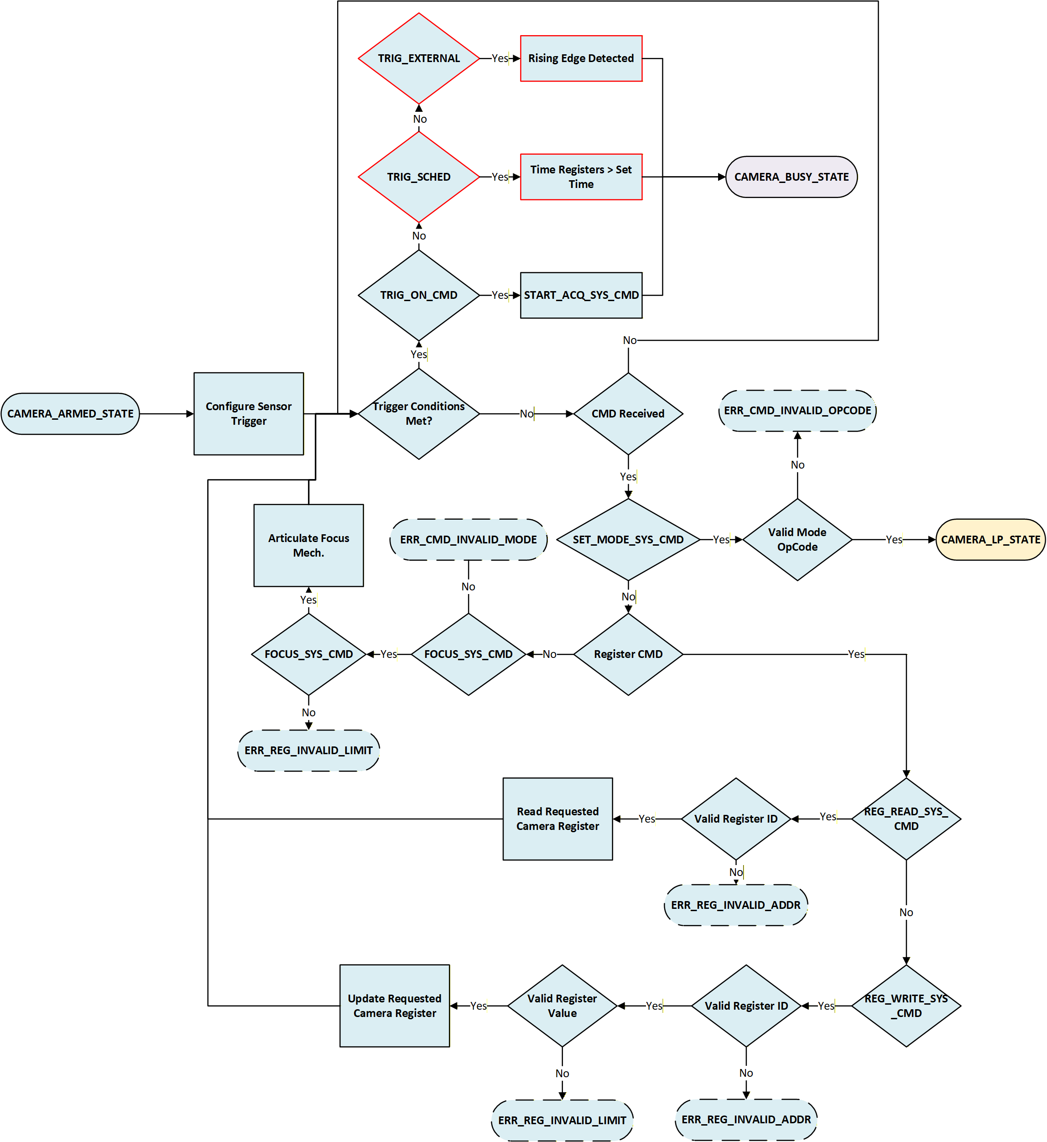

Busy Mode (CAMERA_BUSY_STATE)
Image acquisition with the associate camera configuration as last read during CAMERA_ARMED_STATE occurs in CAMERA_BUSY_STATE which is initiated by the conditions met with the associated set trigger in the SENSOR_TRIG_MODE_SYS_REG camera register.
 | Criteria Description
Entrance Criteria | - FARSIGHT is in CAMERA_ARMED_STATE and exit criteria for CAMERA_ARMED_STATE have been satisfied with the associated trigger conditions as dictated by the trigger mode set in the SENSOR_TRIG_MODE_SYS_REG
Exit Criteria | - CAMERA_LP_STATE entrance criteria satisfied and a valid SET_MODE_SYS_CMD is provided with argument CAMERA_LP_STATE = 0x00  - CAMERA_ARMED_STATE entrance criteria satisfied and a valid SET_MODE_SYS_CMD with argument CAMERA_ARMED_STATE = 0x02  - The camera sensor captures the number of images dictated by the SENSOR_NUM_FRM_TO_CAPTURE_SYS_REG

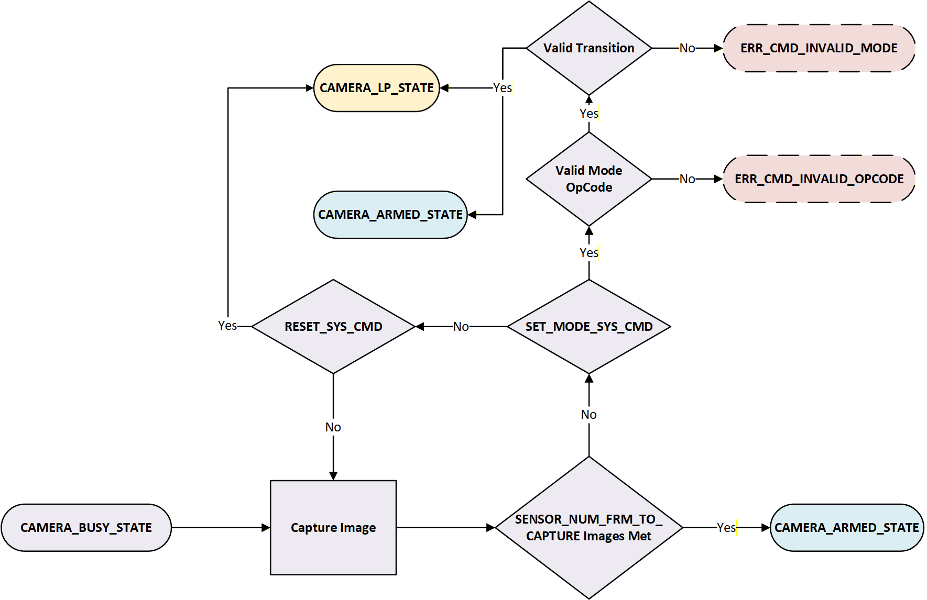

Fault Mode (CAMERA_FAULT_STATE)
If a critical power region in the FAV hardware that has an nfault signal or a critical pgood signal as described by TABLE REF goes low for at least 5 microseconds, the FARSIGHT system will repeatedly send a UART telemetry message through the RS422 lane. The structure of that message can be seen in TABLE REF.

UART Message Format
Power Region | Byte # | Bitfield | Value/Source Status
N/A | 0 | 7:0 | 0xDE
N/A | 1 | 7:0 | 0xAD
N/A | 2 | 7:0 | 0xBE
N/A | 3 | 7:0 | 0xEF
FPGA | 4 | 7 | 3V3 B5 pgood
FPGA | 4 | 6 | 3V3 B4 pgood
FPGA | 4 | 5 | 2V5A pgood
FPGA | 4 | 4 | 1V8 IMX pgood
FPGA | 4 | 3 | 1V8 pgood
FPGA | 4 | 2 | 1V25A pgood
FPGA | 4 | 1 | 1V0A pgood
FPGA | 4 | 0 | 1V0 pgood
FPGA | 5 | 7:1 | Reserved
FPGA | 5 | 0 | 1V0 nfault
LVDS | 6 | 7:1 | Reserved
LVDS | 6 | 0 | 3V3 pgood
DDR16 | 7 | 7:5 | Reserved
DDR16 | 7 | 4 | 0V6 pgood
DDR16 | 7 | 3 | 1V2 pgood
DDR16 | 7 | 2 | 2V5 pgood
DDR16 | 7 | 1 | 1V2 nfault
DDR16 | 7 | 0 | 2V5 nfault
DDR8 | 8 | 7:5 | Reserved
DDR8 | 8 | 4 | 0V6 pgood
DDR8 | 8 | 3 | 1V2 pgood
DDR8 | 8 | 2 | 2V5 pgood
DDR8 | 8 | 1 | 1V2 nfault
DDR8 | 8 | 0 | 2V5 nfault
Step Down Converters | 9 | 7:6 | Reserved
Step Down Converters | 9 | 5 | 4V0 pgood
Step Down Converters | 9 | 4 | 3V0 pgood
Step Down Converters | 9 | 3 | 2V2 pgood
Step Down Converters | 9 | 2 | 4V0 nfault
Step Down Converters | 9 | 1 | 3V0 nfault
Step Down Converters | 9 | 0 | 2V2 nfault
N/A | 10 | 7:0 | 0xBA
N/A | 11 | 7:0 | 0xDD
N/A | 12 | 7:0 | 0xFE
N/A | 13 | 7:0 | 0xED

In the event of a non-critical failure, housekeeper status can be monitored through a REG_READ_SYS_CMD of the HOUSEKEEREP_STATUS_SYS_REG system register, with bitfields corresponding to individual power regions (SEC REF).
Software failures can be detected via the error outputs seen in SEC REF. In the event of a software failure, an update to the firmware may be required.

NOMINAL IMAGING OPERATIONS
In this section we will discuss FARSIGHT imaging operation flow.
The imaging operation flow consists of the following parts:
- Initialization and Health Check
- Camera Configuration
- Focus adjustment
- Image acquisition and offload

IT TAKES AT LEAST 6.8 MILLISECONDS AFTER TRANSITION TO IMAGING MODES TO BEGIN IMAGING. THIS NEEDS TO BE FURTHER CHARACTERIZED THROUGH AVIONICS BOARD TESTING TO PROVIDE A FINAL VALUE.***

Initialization
Before beginning image acquisition, verify operation and health of the FARSIGHT system. Before switching the FARSIGHT camera to CAMERA_IDLE_STATE, verify that the camera is currently in CAMERA_LP_STATE via the REG_READ_SYS_CMD command (reading the SENSOR_STATE_SYS_REG). Also verify the appropriate firmware version is being used via the REG_READ_SYS_CMD command (reading the VERSION_SYS_REG). Send an ECHO_SYS_CMD to verify the return value is what is expected. Complete the functionality check by performing a REG_WRITE_SYS_CMD command to the NOOP_SYS_REG and reading back the register to confirm read/write functionality.

Before switching to idle mode, verify functionality of the DDR4 and ethernet components via a REG_READ_SYS_CMD of the relevant PWRcamera register. Verify bits:

Camera Configuration
Switch the camera to CAMERA_IDLE_STATE via the SET_MODE_SYS_CMD (Op Code = 0x01). During this state, the FARSIGHT Camera Registers can be updated and/or read back to the host. Registers can also be updated in CAMERA_ARMED_STATE and will be used for image capture incident on the next trigger. While registers can be updated while in CAMERA_BUSY_STATE, they will not be recognized as imaging parameters until the SENSOR_NUM_FRM_TO_CAPTURE_SYS_REG value is satisfied and the sensor returns to CAMERA_ARMED_STATE. The protocols for updating both currently implemented writeable camera, system, and network registers can be seen in the tables below:

CAMERA REGISTER | TAKES AFFECT | ACCEPTED MODES | RELEVANT COMMAND
SENSOR_FRM_MOD_SYS_REG | Next Trigger | CAMERA_IDLE_STATE  CAMERA_ARMED_STATE | REG_WRITE_SYS_CMD
SENSOR_BIT_DEPTH_SYS_REG | Next Trigger | CAMERA_IDLE_STATE  CAMERA_ARMED_STATE | REG_WRITE_SYS_CMD
SENSOR_GAIN_SYS_REG | Next Trigger | CAMERA_IDLE_STATE  CAMERA_ARMED_STATE | REG_WRITE_SYS_CMD
SENSOR_BLO_SYS_REG | Next Trigger | CAMERA_IDLE_STATE  CAMERA_ARMED_STATE | REG_WRITE_SYS_CMD
SENSOR_EXPO_USEC_SYS_REG | Next Trigger | CAMERA_IDLE_STATE  CAMERA_ARMED_STATE | REG_WRITE_SYS_CMD
SENSOR_OVER_TEMP_KEL_SYS_REG | Next Trigger | CAMERA_IDLE_STATE  CAMERA_ARMED_STATE | REG_WRITE_SYS_CMD

SYSTEM REGISTER | TAKES AFFECT | ACCEPTED MODES | RELEVANT COMMAND
TRIG_MODE_SYS_REG | Next Trigger | CAMERA_IDLE_STATE  CAMERA_ARMED_STATE | REG_WRITE_SYS_CMD
IMG_PER_TRIGGER_SYS_REG | Next Trigger | CAMERA_IDLE_STATE  CAMERA_ARMED_STATE | REG_WRITE_SYS_CMD
FRAMES_PER_SEC_SYS_REG | Next Trigger | CAMERA_IDLE_STATE  CAMERA_ARMED_STATE | REG_WRITE_SYS_CMD
CAP_START_DLY_USEC_SYS_REG | Next Trigger | CAMERA_IDLE_STATE  CAMERA_ARMED_STATE | REG_WRITE_SYS_CMD
FOCUS_REQ_DIST_M_SYS_REG | Reception of Valid FOCUS_SYS_CMD | CAMERA_LP_STATE  CAMERA_IDLE_STATE  CAMERA_ARMED_STATE  CAMERA_BUSY_STATE | FOCUS_SYS_CMD
TIMESTAMP_UNIX_SYS_REG | Next PPS Rising Edge | CAMERA_LP_STATE  CAMERA_IDLE_STATE  CAMERA_ARMED_STATE  CAMERA_BUSY_STATE | SET_TIME_SYS_CMD
GPO_CONF_SYS_REG | Next Trigger | CAMERA_IDLE_STATE  CAMERA_ARMED_STATE | REG_WRITE_SYS_CMD
GPI_CONF_SYS_REG | Next Trigger | CAMERA_IDLE_STATE  CAMERA_ARMED_STATE | REG_WRITE_SYS_CMD
INTR_PIN_CONF_SYS_REG | Next Trigger | CAMERA_IDLE_STATE  CAMERA_ARMED_STATE | REG_WRITE_SYS_CMD
TRIG_PIN_CONF_SYS_REG | Next Trigger | CAMERA_IDLE_STATE  CAMERA_ARMED_STATE | REG_WRITE_SYS_CMD
TRIG_DELAY_USEC_SYS_REG | Next Trigger | CAMERA_IDLE_STATE  CAMERA_ARMED_STATE | REG_WRITE_SYS_CMD
TRIG_TIMEOUT_MSEC_SYS_REG | Next Trigger | CAMERA_IDLE_STATE  CAMERA_ARMED_STATE | REG_WRITE_SYS_CMD
TMTC_TIMEOUT_MSEC_SYS_REG | Next Trigger | CAMERA_IDLE_STATE  CAMERA_ARMED_STATE | REG_WRITE_SYS_CMD
SRC_MAC_ADDRESS_0_3_SYS_REG | Next Trigger | CAMERA_IDLE_STATE  CAMERA_ARMED_STATE | REG_WRITE_SYS_CMD
SRC_MAC_ADDRESS_4_5_SYS_REG | Next Trigger | CAMERA_IDLE_STATE  CAMERA_ARMED_STATE | REG_WRITE_SYS_CMD
DST_MAC_ADDRESS_0_3_SYS_REG | Next Trigger | CAMERA_IDLE_STATE  CAMERA_ARMED_STATE | REG_WRITE_SYS_CMD
DST_MAC_ADDRESS_4_5_SYS_REG | Next Trigger | CAMERA_IDLE_STATE  CAMERA_ARMED_STATE | REG_WRITE_SYS_CMD
SRC_IP_ADDRESS_SYS_REG | Next Trigger | CAMERA_IDLE_STATE  CAMERA_ARMED_STATE | REG_WRITE_SYS_CMD
DEST_IP_ADDRESS_SYS_REG | Next Trigger | CAMERA_IDLE_STATE  CAMERA_ARMED_STATE | REG_WRITE_SYS_CMD
GATEWAY_SYS_REG | Next Trigger | CAMERA_IDLE_STATE  CAMERA_ARMED_STATE | REG_WRITE_SYS_CMD
SUBNET_MASK_SYS_REG | Next Trigger | CAMERA_IDLE_STATE  CAMERA_ARMED_STATE | REG_WRITE_SYS_CMD
SRC_PORT_SYS_REG | Next Trigger | CAMERA_IDLE_STATE  CAMERA_ARMED_STATE | REG_WRITE_SYS_CMD
DST_PORT_SYS_REG | Next Trigger | CAMERA_IDLE_STATE  CAMERA_ARMED_STATE | REG_WRITE_SYS_CMD

FARSIGHT’s time should be set as a part of the initialization process to ensure that the registered time matches. The SET_TIME_SYS_CMD command will provide FARSIGHT a real time as detailed in the table below and latch this value on the next rising edge of the PPS signal provided to FARSIGHT.
Field | Size (bits) | Bit Range | Description
TIMESTAMP_UNIX_EPOCH_SEC | 32 | 63:32 | Seconds since the epoch (32-bit signed integer, supporting 136 years from the epoch January 1, 1970, for Unix)
TIMESTAMP_SUBSEC_NSEC | 32 | 31:0 | Sub-seconds component of the UNIX time since epoch in nanoseconds

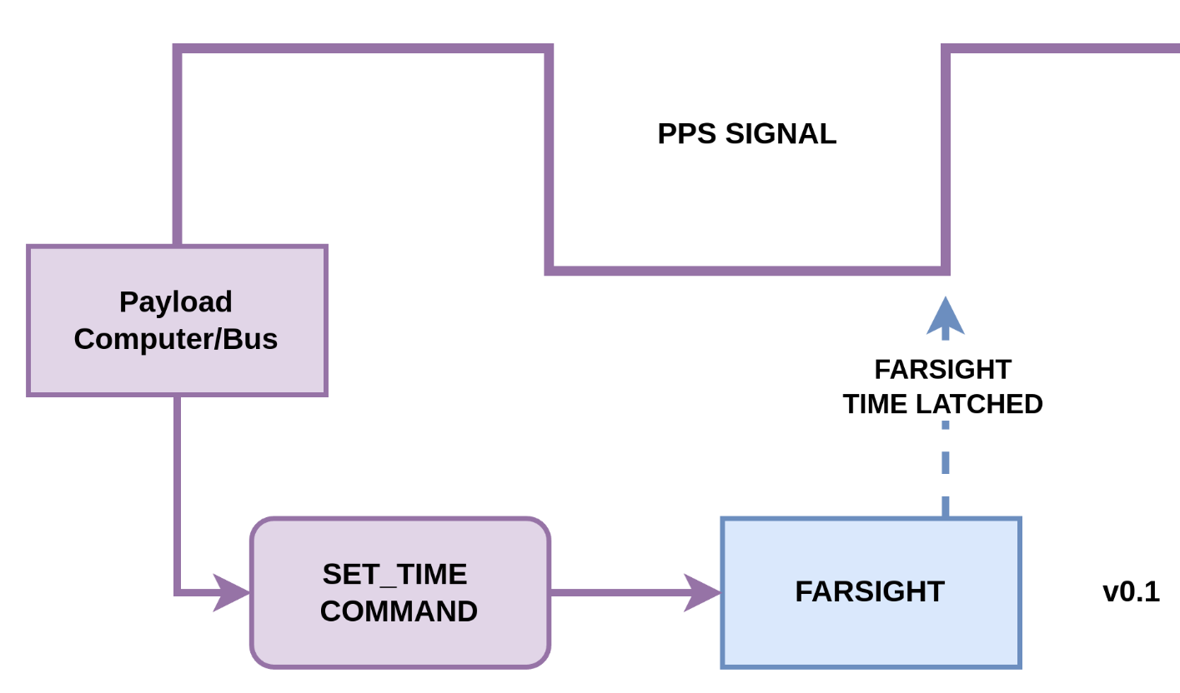
After an initial SET_TIME_SYS_CMD, FARSIGHT will automatically set the TIMESTAMP_UNIX_EPOCH_SEC_SYS and TIMESTAMP_SUBSEC_NSEC_SYS_REG. Depending on integrity of the PPS signal, this setting may or may not reflect the real system time. To mitigate this risk, use a SET_TIME_SYS_CMD before image acquisition.

After ethernet configuration, ping the ETH1 interface to verify functionality.

Before image acquisition, make sure that the camera has been transitioned to CAMERA_ARMED_STATE via a valid SET_MODE_SYS_CMD.

Focusing (Optional)
To adjust the optimal focus point of the FARSIGHT sensor, send a FOCUS_SYS_CMD with the requested target range in meters. This will update the FOCUS_REQ_DIST_M_SYS_REG in the system registers. The FARSIGHT focus mechanism articulates in response to a valid command. The focus mechanism takes approximately 2 seconds to travel the entire throw of the focus mechanism. Verification of the articulation of the focus mechanism can be done via a REG_READ_SYS_CMD of the FOCUS_COMP_DIST_M_SYS_REG or FOCUS_LVDT_POS_NM_REG registers. Allow the focus mechanism ample time to reach its focus point before initiating image acquisition. The focus mechanism can be articulated while the camera is in any mode outside of the CAMERA_FAULT_STATE mode.

Image Acquisition and Offload
Image acquisition begins after the associated trigger conditions dictated by the SENSOR_TRIG_MODE_SYS_REG. The camera sensor will then enter CAMERA_BUSY_STATE and capture images using the settings dictated by the associated register values at the time of trigger recognition. The camera will capture the number of images dictated by the SENSOR_NUM_FRM_TO_CAPTURE_SYS_REG and store them to the DDR4 frame buffer starting with the index set by the BUFF_WRITE_INDEX_SYS_REG. After finishing image acquisition, the camera will automatically return back to CAMERA_STATE_ARMED and await the next trigger. The camera can also be returned back to CAMERA_LP_STATE or CAMERA_IDLE_STATE via a valid SET_MODE_SYS_CMD.

To offload images off the frame buffer, send an XFER_BUFF_SYS_CMD command with the associated image index and number of frames.

PPS TIMEKEEPING:
The external 1PPS signal synchronizes the real system time to the internal FARSIGHT time. This can be explicitly called for with a SET_TIME_SYS_CMD but will be automatic with the host to FAV 1PPS. The FARSIGHT internal clock has a frequency of 50 MHz and will handle internal time keeping in reference to the received 1PPS pulse signal. An 8-sample moving average is used to calculate the average period of input for the 1PPS. This period is used to verify whether an input 1PPS is ignored.
Each time a 1PPS comes in, the duration since the last 1PPS pulse is checked. If the duration since last PPS input is <50% or >150% of the expected 1 PPS period governed by the tick count since last 1PPS signal, that signal is then ignored and will not affect local timekeeping registers.
It is recommended that a SET_TIME_SYS_CMD proceeds all imaging activities to mitigate potential errors.

RESETS & WATCHDOGS:
Resets of the FARSIGHT system are either initiated with a valid RESET_SYS_CMD or by initiating a power cycle. The valid resets are:
- Camera Sensor Reset (RESET_SYS_CMD – Bit 0): Reset of the camera sensor into CAMERA_LP_STATE
- Focus Mechanism Reset (RESET_SYS_CMD – Bit 1): Reset all focus mechanism faults and stop driving the motor controllers at their current position
- Register Reset (RESET_SYS_CMD – Bit 2): Reset the camera registers to their default values
- Power Cycle: Cut power to the NPS Channel and reenable to initiate a power cycle, which will re-initialize the boot sequence

RISCV Processor Watchdog: In case of RISCV processor fatal exception the core will be captured in the trap handler until the core is reset. A watchdog timer is implemented in the PolarFire FPGA to watch for Software hangs and reset the RISCV core. Upon Software reset the application will initialize all the Software registers and will place the IMX camera into a known state. The details of WDT and after reset status capture is included in SDD. *Future Implementation

LATCHUP & BOOT FAILURE RESPONSE:
When latchups from radiation events or components fail to boot, FARSIGHT responds depending on the criticality and circumstance of the failure. There are two primary responses:
FARSIGHT enters (or stays in) BOOT_MODE and beacons a statically sized UART packet that provides information on state/failure of critical power regions or DDR4 if a latchup occurs.
This occurs when a critical power region fails to boot OR latches up
This occurs when DDR4 latches up but DOES NOT occur if DDR4 fails to boot. During the boot process, failures will be reported on DDR, but the boot process wil continue since it is not a critical memory section.
When this response occurs, a Power on Reset is required to rectify the error.
FARSIGHT disables power regions with higher boot orders than the failed power region as long a this region is a PolarFire SW controlled region as defined in the table below.
When this response occurs, it is recommended to power cycle FARSIGHT after requesting telemetry.
These failures can be detected by regularly checking the relevant FARSIGHT system registers

SOFTWARE TMTC INTERFACE
In this section we will define the Telemetry and Telecommand (TMTC) interface between the host computer (HOST) and FARSIGHT Avionics computer (FAV). Before going over the details let’s go over some terminologies used in this section.
Table 5-1: Software TMTC Interface Terminologies
Term | Description
Host | Host is the computer that communicates with the FARSIGHT Avionics Computer by sending telecommands (TC) and receiving telemetry (TL).
TMTC Packet | Telemetry and Telecommand packet is a formatted unit of data that is transmitted between the Host and FAV. TMTC Packet consists of a Header and a Datagram.
Datagram | Datagram or payload is the actual information or message being sent between FAV and Host. A Datagram can contain its own header format plus payload data or can only contain the payload data without any extra header.
Command | Commands are a set of instructions sent from the host to the FARSIGHT Avionics computer to control operations and configuration of the FARSIGHT payload.
Science Payload | FARSIGHT science data payload are images captured by the FARSIGHT camera sensor.

SERIAL INTERFACE
A quick reference for FARSIGHT’s serial debug and backup TMTC interface is provided in the table below.
Table 5-2: FARSIGHT’s Serial Debug and Backup TMTC Interface Quick Reference
Parameter | Value
Stop Bits | 1
Parity | None
Data size | 8-bits
Baud Rate | 115200 (default, but configurable)

TMTC PACKET FORMAT
FARSIGHT has a custom packetization protocol whose packet format is defined in Figure 5-1. This protocol operates in a synchronous point-to-point request-reply pattern in which the host (computer interfacing with FARSIGHT) will send a command and then receive a response from FARSIGHT Avionics Computer (FAV) based on that command. This packet information is always sent from the most significant byte (MSB) first.

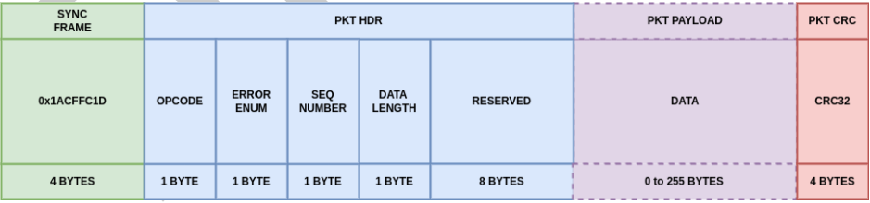
Figure 5-1:TMTC Packet Format
The CRC-32 is calculated over all bytes except sync frame for data integrity verification.
The FARSIGHT TMTC protocol uses mixed byte ordering. All packet framing and header fields (sync frame, reserved, and CRC) are transmitted in big-endian (most significant byte first) order. Single-byte fields (opcode, error code, sequence number, and data length) have no byte-order dependency. The data payload is transmitted in little-endian (least significant byte first) order, consistent with the native byte order of the RISC-V processor on the FAV.

PKT_HDR
Total Size: 16 bytes
Description: This packet header provided the FAV and host with sufficient information to decode commands and telemetry packets. See Table 5-3 for a breakdown of each field within this header.
Field | Size (bits) | Description | Byte Order
SYNC  FRAME | 32 | Used to indicate the start of a packet.  SYNC FRAME FOR PACKET WILL ALWAYS BE 0x1ACFFC1D (Transmitted as 0x1A, 0xCF, 0xFC, 0x1D) | Big-endian
Opcode | 8 | Command or function code identifying the operation | -
Error Code | 8 | Error status (used in reply packets from FAV) | -
Sequence Number | 8 | Packet sequence counter for tracking purposes | -
Reserved | 64 | Reserved for future functionality implementations | Big-endian
Table 5-3: Packet Header Field Descriptions

PKT_DATA
Field with a maximum size of 255 bytes including data described by the TMTC packet header. When packet is sent from the Host to the FAV this field will include command parameters, the format of which is described for each command in section 5.3 FARSIGHT COMMANDS. When a packet is sent from the FAV to the Host in response to a REG_READ_SYS_CMD (see section 5.3.2.4 REG_READ_SYS_CMD), then data will be formatted as described in the representative register definition seen in sec ref – sec ref. For multi-argument commands, the FAV expects data ordered by the argument numbers given in SEC REF – SEC REF. An example can be seen below for a REG_WRITE_SYS_CMD.
PLACEHOLDER

TL DATAGRAM FORMAT
When the packet is sent from the FAV to the Host in response to a REG_READ_SYS_CMD a TL DATAGRAM will be provided as seen in the figure below. Currently, all registers are 32-bit data packets of one or multiple fields.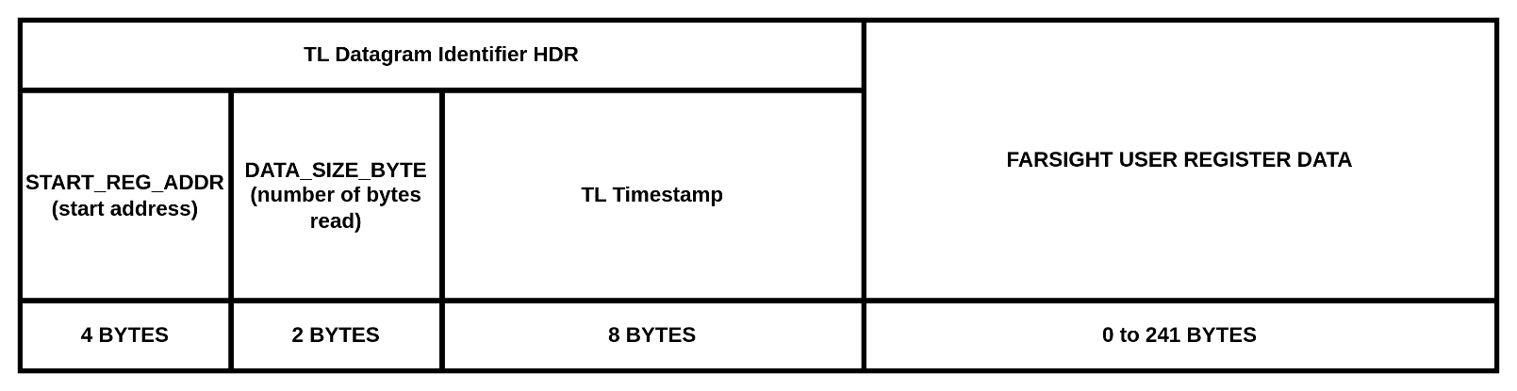
Figure 5-2: TL Event, TL Channel & Raw Image Segment Datagram Formatting

FARSIGHT COMMANDS
FARSIGHT’s commands are defined within this section. Many of these commands will lead to specific operations guided by the register map defined in Section 5.5 FARSIGHT REGISTERS.

COMMAND | OPCODE | DESCRIPTION
GET_VERSION_SYS_CMD | 0x00 | Get HW and SW version Info
SET_MODE_SYS_CMD | 0x01 | Put camera in indicated mode
RESET_SYS_CMD | 0x02 | Resets the FARSIGHT subsystems
REG_READ_SYS_CMD | 0x03 | Reads a specified register value
REG_WRITE_SYS_CMD | 0x04 | Writes a value to a specified register
SET_TIME_SYS_CMD | 0x05 | Sets FARSIGHT’s absolute system time
START_ACQ_SYS_CMD | 0x06 | Starts an image acquisition
STOP_ACQ_SYS_CMD | 0x07 | Stops an image acquisition
FOCUS_SYS_CMD | 0x08 | Initiates a focus operation
HALT_FOCUS_SYS_CMD | 0x09 | Stop focus operation
XFER_BUFF_SYS_CMD | 0x0A | Transfers a section of the DDR4 frame buffer
RESET_BUFF_SYS_CMD | 0x0B | Update focus mechanism calibration table
GET_INFO_SYS_CMD | 0x0C | Get system information in regards to register allowances
CONF_EVENT_LOG_SYS_CMD | 0x0D | Configure the event log.
EN_TL_CHAN_LOG_SYS_CMD | 0x0E | Command to configure LOG buffer.
XFER_LOG_SYS_CMD | 0x0F | Transfer LOG from FAV to host

Error Enumerations
ERROR | ENUM | DESCRIPTION
NO_ERROR | 0x00 | No error has occurred
ERR_CMD_INVALID_MODE | 0x01 | A command was rejected due to the current mode of the payload
ERR_CMD_INVALID_OPCODE | 0x02 | Command was determined to be invalid based on opcode
ERR_PKT_INVALID_HDR_CRC | 0x03 | Packet HEADER_CRC failed validation
ERR_PKT_INVALID_DATA_CRC | 0x04 | Packet DATA_CRC failed validation for commands with arguments
ERR_PKT_INVALID_DATA_LEN | 0x05 | Packet USER_DATA_LENGTH field was invalid
ERR_PKT_INVALID_HDR_PARAM | 0x06 | Invalid packet header parameter value
ERR_REG_INVALID_ADDR | 0x07 | Register address was invalid
ERR_REG_INVALID_LIMIT | 0x08 | Parameter update was determined invalid due to the value's limits
ERR_REG_WRITE_DENIED_RO | 0x09 | The telemetry value was read only
ERR_REG_MODE_REJECTED | 0x0A | A register write was rejected due to the current mode of the payload
ERR_TBD | ... | Additional error codes are expected to be added

Command Descriptions
Command descriptions are tabulated throughout this section. Error responses specific to the command are also provided. Although not documented in these tables, common errors are listed below:
INVALID_HDR_CRC error – returned if the HEADER_CRC field does not match the CRC computed by FARSIGHT on the header
INVALID_DATA_CRC error – returned if the DATA_CRC field does not match the CRC computed by FARSIGHT on the data field for commands that include data here
INVALID_CMD error – the opcode provided does not exist in FARSIGHT’s command table

GET_VERSION_SYS_CMD
NAME | VALUE
Description | This command will get information on the current HW and SW versions of the FARSIGHT system.
Opcode | 0x00
Accepted Modes | CAMERA_LP_STATE  CAMERA_IDLE_STATE  CAMERA_ARMED_STATE  CAMERA_BUSY_STATE
Invalid Modes | CAMERA_FAULT_STATE
Arguments | No unique arguments identified
Return Value | TBD
Command Specific Errors | PLACEHOLDER

SET_MODE_SYS_CMD
NAME | VALUE
Description | This command will transition the camera sensor to various operational states.
Opcode | 0x01
Accepted Modes | CAMERA_LP_STATE  CAMERA_IDLE_STATE  CAMERA_ARMED_STATE  CAMERA_BUSY_STATE
Invalid Modes | CAMERA_FAULT_STATE
Argument 1 | Parameter Name: | MODE
Argument 1 | Type: | uint8_t
Argument 1 | Length (bytes): | 1
Argument 1 | Description: | Enumeration of different camera states:  - 0x00: CAMERA_LP_STATE  - 0x00: CAMERA_UPDATE_STATE  - 0x01: CAMERA_IDLE_STATE  - 0x02: CAMERA_ARMED_STATE
Argument 1 | Valid Values: | 0x00 to 0x03
Return Value | None
Command Specific Errors | TBD

RESET_SYS_CMD
NAME | VALUE
Description | This command will perform a reset of various FARSIGHT subsystems
Opcode | 0x02
Accepted Modes | CAMERA_LP_STATE  CAMERA_IDLE_STATE  CAMERA_ARMED_STATE  CAMERA_BUSY_STATE
Invalid Modes | CAMERA_FAULT_STATE
Argument 1 | Parameter Name: | target_reset
Argument 1 | Type: | uint8_t
Argument 1 | Length (bytes): | 1
Argument 1 | Description: | Bit field to specify the target subsystem to be reset:  - Bit 0: RESET_CAM_SENSOR, setting this bit will put the sensor in the Low Power Mode and reset registers to default values  - Bit 1: RESET_FOCUS_MECH, setting this bit will reset all the focus mechanism faults and stop driving the motor controllers at their current position.  - Bit 2: RESET_REG_SPACE, setting this bit will reset all the firmware registers to their default values.  - Bit 3: RESET_MEM_BUFF, setting this bit will reset the image frame memory buffer to index.  - Bit 7-4: Not used.
Argument 1 | Valid Values: | 0x00 to 0x0F
Return Value | None
Command Specific Errors | TBD

REG_READ_SYS_CMD
NAME | VALUE
Description | This command will read a specified register value.
Opcode | 0x03
Accepted Modes | CAMERA_LP_STATE  CAMERA_IDLE_STATE  CAMERA_ARMED_STATE  CAMERA_BUSY_STATE  CAMERA_FAULT_STATE
Invalid Modes | N/A
Argument 1 | Parameter Name: | reg_id
Argument 1 | Type: | uint8_t
Argument 1 | Length (bytes): | 1
Argument 1 | Description: | Register ID to read
Argument 1 | Valid Values: | 0x00 to 0xFF
Return Value | uint32_t
Command Specific Errors | PLACEHOLDER

REG_WRITE_SYS_CMD
NAME | VALUE
Description | This command will update a specified register value.
Opcode | 0x04
Accepted Modes | CAMERA_IDLE_STATE  CAMERA_ARMED_STATE  CAMERA_BUSY_STATE
Invalid Modes | CAMERA_LP_STATE  CAMERA_FAULT_STATE
Argument 1 | Parameter Name: | REG_ID
Argument 1 | Type: | uint8_t
Argument 1 | Length (bytes): | 1
Argument 1 | Description: | Register ID to read
Argument 1 | Valid Values: | 0x00 to 0xFF
Argument 2 | Parameter Name: | REG_VALUE
Argument 2 | Type: | uint32_t
Argument 2 | Length (bytes): | 4
Argument 2 | Description: | Register value
Argument 2 | Valid Values: | Varied based on the register. See SEC REF for more info.
Return Value | None
Command Specific Errors | PLACEHOLDER

SET_TIME_SYS_CMD
NAME | VALUE
Description | After receiving this command, the time stamp of FARSIGHT will be set on the next rising edge of the PPS signal
Opcode | 0x05
Accepted Modes | CAMERA_LP_STATE  CAMERA_IDLE_STATE  CAMERA_ARMED_STATE  CAMERA_BUSY_STATE
Invalid Modes | CAMERA_FAULT_STATE
Argument 1 | Parameter Name: | TIMESTAMP_UNIX_EPOCH_SEC
Argument 1 | Type: | uint32_t
Argument 1 | Length (bytes): | 4
Argument 1 | Description: | Whole seconds of the UTC timestamp express as the number of seconds elapsed since the UNIX epoch (January 1, 1970 00:00:00 UTC). This value is latched on the next rising edge of the PPS signal.
Argument 1 | Valid Values: | 0x0000_0000 to 0xFFFF_FFFF
Argument 2 | Parameter Name: | TIMESTAMP_SUBSEC_NSEC
Argument 2 | Type: | uint32_t
Argument 2 | Length (bytes): | 4
Argument 2 | Description: | Sub-second portion of the UTC timestamp in nanoseconds. Combined with TIMESTAMP_UNIX_EPOCH_SEC, this provides microsecond resolution time synchronization. This value is latched on the next rising edge of the PPS signal.
Argument 2 | Valid Values: | Varied based on the register. See SEC REF for more info.
Return Value | None
Command Specific Errors | PLACEHOLDER

START_ACQ_SYS_CMD
NAME | VALUE
Description | Requests FARSIGHT to take pictures upon receiving this command. This command will only take effect if register SENSOR_TRIG_MOD_SYS_REG is set to TRIG_ON_CMD value. For other trigger configurations an error will be returned.
Opcode | 0x06
Accepted Modes | CAMERA_ARMED_STATE
Invalid Modes | CAMERA_LP_STATE  CAMERA_IDLE_STATE  CAMERA_BUSY_STATE  CAMERA_FAULT_STATE
Arguments | No unique arguments identified
Return Value | None
Command Specific Errors | PLACEHOLDER

STOP_ACQ_SYS_CMD
NAME | VALUE
Description | Requests FARSIGHT to halt image acquisition effective immediately and return the camera to the CAMERA_LP_STATE.
Opcode | 0x07
Accepted Modes | CAMERA_BUSY_STATE
Invalid Modes | CAMERA_LP_STATE  CAMERA_IDLE_STATE  CAMERA_ARMED_STATE  CAMERA_FAULT_STATE
Arguments | No unique arguments identified
Return Value | None
Command Specific Errors | PLACEHOLDER

FOCUS_SYS_CMD
NAME | VALUE
Description | Calculates a focus distance and commands motion to that position.
Opcode | 0x08
Accepted Modes | CAMERA_LP_STATE  CAMERA_IDLE_STATE  CAMERA_ARMED_STATE  CAMERA_BUSY_STATE
Invalid Modes | CAMERA_FAULT_STATE
Argument 1 | Parameter Name: | RAW_POS
Argument 1 | Type: | uint32_t
Argument 1 | Length (bytes): | 4
Argument 1 | Description: | Target conjugate distance in m
Argument 1 | Valid Values: | 5000 - 10000000
Return Value | TBD
Command Specific Errors | PLACEHOLDER

HALT_FOCUS_SYS_CMD
NAME | VALUE
Description | Requests FARSIGHT to halt focusing commands effective immediately.
Opcode | 0x09
Accepted Modes | CAMERA_BUSY_STATE  CAMERA_LP_STATE  CAMERA_IDLE_STATE  CAMERA_ARMED_STATE
Invalid Modes | CAMERA_FAULT_STATE
Arguments | No unique arguments identified
Return Value | None
Command Specific Errors | PLACEHOLDER

XFER_BUFF_SYS_CMD
NAME | VALUE
Description | This command initiates the transfer of files from the DDR4 frame buffer to the bulk data storage aboard the spacecraft.
Opcode | 0x0A
Accepted Modes | CAMERA_LP_STATE  CAMERA_IDLE_STATE  CAMERA_ARMED_STATE
Invalid Modes | CAMERA_BUSY_STATE  CAMERA_FAULT_STATE
Argument 1 | Parameter Name: | IMAGE_INDEX
Argument 1 | Type: | uint16_t
Argument 1 | Length (bytes): | 2
Argument 1 | Description: | Image index. Range from 0 to 767 where the first 0 to 511 indexes will point to DDR4 16GB and 512 to 767 indexes will refer to DDR4 8GB.
Argument 1 | Valid Values: | 0x0000 to 0x02FF
Argument 2 | Parameter Name: | NUM_IMAGES
Argument 2 | Type: | uint16_t
Argument 2 | Length (bytes): | 2
Argument 2 | Description: | Number of images to transfer. If the requested number of images is larger than the mnax allowable in the memory buffer an error will be returned. If index + requested number of images is greater than max index range an error will be returned
Argument 2 | Valid Values: | 0x0001 to 0x0300
Return Value | None
Command Specific Errors | PLACEHOLDER

RESET_BUFF_SYS_CMD
NAME | VALUE
Description | Resets the buffer write pointer to a specific memory location.
Opcode | 0x0B
Accepted Modes | CAMERA_LP_STATE  CAMERA_IDLE_STATE  CAMERA_ARMED_STATE
Invalid Modes | CAMERA_BUSY_STATE  CAMERA_FAULT_STATE
Argument 1 | Parameter Name: | BUFF_START_ADDR
Argument 1 | Type: | uint16_t
Argument 1 | Length (bytes): | 2
Argument 1 | Description: | Image index. Range from 0 to 767 where the first 0 to 511 indexes will point to DDR4 16GB and 512 to 767 indexes will refer to DDR4 8GB.
Argument 1 | Valid Values: | 0x0000 to 0x02FF
Return Value | None
Command Specific Errors | PLACEHOLDER

GET_INFO_SYS_CMD
NAME | VALUE
Description | Resets the buffer write pointer to a specific memory location.
Opcode | 0x0C
Accepted Modes | CAMERA_IDLE_STATE  CAMERA_ARMED_STATE
Invalid Modes | CAMERA_LP_STATE  CAMERA_BUSY_STATE  CAMERA_FAULT_STATE
Argument 1 | Parameter Name: | REG_ADDR
Argument 1 | Type: | uint16_t
Argument 1 | Length (bytes): | 2
Argument 1 | Description: | Target Register Address
Argument 1 | Valid Values: | Register addresses listed in SEC REF
Return Value | None
Command Specific Errors | PLACEHOLDER

CONF_EVENT_LOG_SYS_CMD
NAME | VALUE
Description | Configure the event log
Opcode | 0x0D
Accepted Modes | CAMERA_IDLE_STATE  CAMERA_ARMED_STATE  CAMERA_LP_STATE
Invalid Modes | CAMERA_BUSY_STATE  CAMERA_FAULT_STATE
Argument 1 | Parameter Name: | LOG_LEVEL
Argument 1 | Type: | unit8_t
Argument 1 | Length (bytes): | 1
Argument 1 | Description: | Enumeration of different log levels to record events:  - DIAGNOSTIC = 0x00  - ACTIVITY_LO = 0x01  - ACTIVITY_HI = 0x02  - WARNING_LO = 0x03  - WARNING_HI = 0x04  - FATAL = 0x05  - COMMAND = 0x06  All event with a value equal to or higher than the provided LOG_LEVEL will be recorded to FARSIGHT’s circular non-volatile TL event log for later request through XFER_LOG_SYS_CMD.
Argument 1 | Valid Values: | 0x00 – 0x06
Return Value | None
Command Specific Errors | PLACEHOLDER

EN_TL_CHAN_LOG_SYS_CMD
c | VALUE
Description | Command to configure LOG buffer.
Opcode | 0x0E
Accepted Modes | CAMERA_IDLE_STATE  CAMERA_ARMED_STATE  CAMERA_LP_STATE
Invalid Modes | CAMERA_BUSY_STATE  CAMERA_FAULT_STATE
Argument 1 | Parameter Name: | CHANNEL_ADDR
Argument 1 | Type: | uint16_t
Argument 1 | Length (bytes): | 2
Argument 1 | Description: | Target Register Address
Argument 1 | Valid Values: | Register addresses listed in SEC REF
Argument 2 | Parameter Name: | LOG_RATE
Argument 2 | Type: | uint8_t
Argument 2 | Length (bytes): | 1
Argument 2 | Description: | LOG_RATE in 1/10 Hz increments. This channel will be logged to FARSIGHT’s circular non-volatile TL channel log for later request through XFER_LOG_SYS_CMD
Argument 2 | Valid Values: | 0x00 – 0xFF
Return Value | None
Command Specific Errors | PLACEHOLDER

XFER_LOG_SYS_CMD
NAME | VALUE
Description | Request transfer of LOG file from FARSIGHT Avionics NVM to Payload computer
Opcode | 0x0F
Accepted Modes | CAMERA_IDLE_STATE  CAMERA_ARMED_STATE  CAMERA_LP_STATE
Invalid Modes | CAMERA_BUSY_STATE  CAMERA_FAULT_STATE
Argument 1 | Parameter Name: | LOG
Argument 1 | Type: | unit8_t
Argument 1 | Length (bytes): | 1
Argument 1 | Description: | Enumeration of different log levels to record events:  - TL_EVENT_LOG = 0x01 (only transfers the event log)  - TL_CHANNEL_LOG = 0x02 (only transfers the channel log)  - FULL_LOG = 0x03 – 0xFF (transfers the entire log, maximum of 2 MB)
Argument 1 | Valid Values: | 0x00 – 0x06
Return Value | None
Command Specific Errors | PLACEHOLDER

FARSIGHT REGISTERS
FARSIGHT registers are organized into several groups for convenience. These registers live in a single contiguous memory space where each address represents the previous register’s address + the previous registers size. Within the tables below, the following attributes of each register are provided: address, size, data type, R/W access and if the value persists across reboots. For additional details on each register, please reference the registers individual section within section 5.6 REGISTER DESCRIPTIONS. Data types assigned to registers are described below for convenience:
TYPE | EXAMPLES | DESCRIPTION
uint<bit_depth>_t | uint8_t, uint16_t | Unsigned integer with number of bits = bit_depth
int<bit_depth>_t | int8_t, int16_t | Signed integer with number of bits = bit_depth
uint<bit_depth>_t (bitfield) | uint8_t (bitfield) | Bitfield where each bit has a specific meaning
uint<bit_depth>_t (enum) | uint8_t (enum) | Enumeration where each value has a specific meaning
uint<bit_depth>_t[array_size] | uint8_t[4], uint32_t[2] | Unsigned integer array of size array_size with each value having number of bits = bit_depth
int<bit_depth>_t[array_size] | int8_t[4], int32_t[2] | Signed Integer Array of size array_size with each value having number of bits = bit_depth

CAMERA STATUS AND CONTROL REGISTERS

REGISTER NAME | ADDRESS | SIZE (BYTES) | DATA TYPE | R/W | SAVED?
SENSOR_STAT_SYS_REG | 0x00 | 4 | uint32_t | RO | No
SENSOR_FRM_MOD_SYS_REG | 0x01 | 4 | uint32_t | R/W | No
SENSOR_BIT_DEPTH_SYS_REG | 0x02 | 4 | uint32_t | R/W | No
SENSOR_GAIN_SYS_REG | 0x03 | 4 | uint32_t | R/W | No
SENSOR_BLO_SYS_REG | 0x04 | 4 | uint32_t | R/W | No
SENSOR_EXPO_USEC_SYS_REG | 0x05 | 4 | uint32_t | R/W | No
SENSOR_TEMP_KEL_SYS_REG | 0x06 | 4 | uint32_t | RO | No
SENSOR_OVER_TEMP_KEL_SYS_REG | 0x07 | 4 | uint32_t | R/W | No

SYSTEM REGISTERS

REGISTER NAME | ADDRESS | SIZE (BYTES) | DATA TYPE | R/W | SAVED?
ERROR_RESET_REG | 0x09 | 4 | uint32_t
FPGA_VOLTAGE_TEMP_SYS_REG | 0x0A | 4 | uint32_t | RO
PWR_STATUS_REG | 0x0B | 4 | uint32_t | RO
ERROR_COUNT_SYS_REG | 0x0C | 4 | uint32_t | RO | Yes
BOOT_COUNT_SYS_REG | 0x0D | 4 | uint32_t | RO | Yes
UPTIME_SEC_SYS_REG | 0x03 | 4 | uint32_t | RO
TIMESTAMP_UNIX_SYS_REG | 0x0F | 8 | uint32_t[2] | RO | No
WDOG_TIMEOUT_MSEC_SYS_REG | 0x10 | 4 | uint32_t | R/W | Yes
BUFF_WRITE_POLICY_SYS_REG | 0x10 | 4 | uint32_t | R/W | No
BUFF_WRITE_PTR_SYS_REG | 0x11 | 4 | uint32_t | RO | No
BUFF_BYTES_AVAIL_L_SYS_REG | 0x12 | 4 | uint32_t
BUFF_BYTES_AVAIL_M_SYS_REG | 0x13 | 4 | uint32_t

SYSTEM REGISTERS

REGISTER NAME | ADDRESS | SIZE (BYTES) | DATA TYPE | R/W | SAVED?
TRIG_MODE_SYS_REG | 0x14 | 4 | uint32_t | R/W | No
IMG_PER_TRIGGER_SYS_REG | 0x15 | 4 | uint32_t | R/W | No
FRAMES_PER_SEC_SYS_REG | 0x16 | 4 | uint32_t | R/W | No
CAP_START_DLY_USEC_SYS_REG | 0x17 | 4 | uint32_t | R/W | No
FRAME_COUNT_SYS_REG | 0x18 | 4 | uint32_t | RO | Yes
FOCUS_REQ_DIST_M_SYS_REG | 0x19 | 4 | uint32_t | RO | No
FOCUS_COMP_DIST_M_SYS_REG | 0x1A | 4 | uint32_t | RO | No
FOCUS_LVDT_POS_NM_REG | 0x1B | 4 | int32_t | RO | No
IMAGE_BUFFER_SELECT_REG | 0x1C | 4 | uint32_t

SYSTEM COMMUNICATION REGISTERS

REGISTER NAME | ADDRESS | SIZE (BYTES) | DATA TYPE | R/W | SAVED?
GPO_CONF_SYS_REG | 0x1D | 4 | uint32_t | R/W | No
GPI_CONF_SYS_REG | 0x1E | 4 | uint32_t | R/W | No
INTR_PIN_CONF_SYS_REG | 0x1F | 4 | uint32_t | R/W | No
TRIG_PIN_CONF_SYS_REG | 0x20 | 4 | uint32_t | R/W | No
TRIG_DELAY_USEC_SYS_REG | 0x21 | 4 | uint32_t | R/W | No
TRIG_TIMEOUT_MSEC_SYS_REG | 0x22 | 4 | uint32_t | R/W | No
TMTC_TIMEOUT_MSEC_SYS_REG | 0x23 | 4 | uint32_t | R/W | No
SRC_MAC_ADDRESS_0_3_SYS_REG | 0x24 | 4 | uint32_t
SRC_MAC_ADDRESS_4_5_SYS_REG | 0x25 | 4 | uint32_t
DST_MAC_ADDRESS_0_3_SYS_REG | 0x26 | 4 | uint32_t
DST_MAC_ADDRESS_4_5_SYS_REG | 0x27 | 4 | uint32_t
SRC_IP_ADDRESS_SYS_REG | 0x28 | 4 | uint32_t
DEST_IP_ADDRESS_SYS_REG | 0x29 | 4 | uint32_t
GATEWAY_SYS_REG | 0x2A | 4 | uint32_t | R/W | No
SUBNET_MASK_SYS_REG | 0x2B | 4 | uint32_t | R/W | No
SRC_PORT_SYS_REG | 0x2C | 4 | uint32_t
DST_PORT_SYS_REG | 0x2D | 4 | uint32_t

SYSTEM VERSION REGISTERS

REGISTER NAME | ADDRESS | SIZE (BYTES) | DATA TYPE | R/W | SAVED?
FAV_DEVICE_ID_SYS_REG | 0x2E | 4 | uint32_t | RO | Yes
SENSOR_ID_SYS_REG | 0x2F | 4 | uint32_t | RO | Yes
TMTC_VERS_SYS_REG | 0x30 | 4 | uint32_t | RO | Yes
SW_VERS_SYS_REG | 0x31 | 4 | uint32_t | RO | Yes
PF_FW_VERS_SYS_REG | 0x32 | 4 | uint32_t | RO | Yes
P3_FW_VERS_SYS_REG | 0x33 | 4 | uint32_t | RO | Yes

TEST & INTEGRATION

REGISTER NAME | ADDRESS | SIZE (BYTES) | DATA TYPE | R/W | SAVED?
ENABLE_IMX_TEST_IMG | 0x34 | 4 | uint32_t
NOOP_REG | 0x35 | 4 | uint32_t | R/W | No
NUMBER_REGISTERS | 0x36 | 4 | uint32_t | RO | Yes

CAMERA STATUS & CONTROL REGISTER DESCRIPTIONS
This section includes tabulated descriptions of FARSIGHT user registers. Reference sections 5.4.1 - 5.4.6 for address, R/W access and if the register’s value persists across resets.

SENSOR_STAT_SYS_REG
Description | The current status of FARSIGHT’s camera sensor.
Access | Read Only
Address | 0x00
Data Type | unit32_t
Reset Value | 0x0000_0000 (DISABLED)
Enumeration Values | Value | Enumeration | Description
Enumeration Values | 0x0000_0000 | DISABLED | When the sensor is currently disabled and cannot initial an acquisition
Enumeration Values | 0x0000_0001 | STANDBY | When the sensor can be configured but is not ready to take images
Enumeration Values | 0x0000_0002 | ARMED | Sensor is capable of capturing images
Enumeration Values | 0x0000_0003 | N/A | This bit is not applicable and will result in returned error

SENSOR_FRM_MOD_SYS_REG
Description | Configuration defining frame modification included in default sensor features
Access | Read/Write
Address | 0x01
Data Type | unit32_t (bitfield)
Reset Value | 0x00 (see below)
Bitfield Description | Bitfield Value | Index | Description
Bitfield Description | RESERVED | 31:4 | Reserved bits
Bitfield Description | READOUT_MODE | 3:2 | 2-bit enumerated value, values described below:
Bitfield Description | READOUT_MODE | 3:2 | Value | Meaning | Image Size
Bitfield Description | READOUT_MODE | 3:2 | 0 | All-pixel Scan | 4504x4504
Bitfield Description | READOUT_MODE | 3:2 | 1 | 2x2 binning | 2252x2252
Bitfield Description | READOUT_MODE | 3:2 | 2 | ½ subsampling | 2252x2252
Bitfield Description | READOUT_MODE | 3:2 | 3 | All-pixel scan | 4504x4504
Bitfield Description | VERT_INVERSION | 1 | If set to 1, then the image will have its vertical axis inverted
Bitfield Description | HORIZ_INVERSION | 0 | If set to 1, then the image will have its horizontal axis inverted

SENSOR_BIT_DEPTH_SYS_REG
Description | The bit-depth of the images that FARSIGHT’s sensor will output. This parameter has been identified as a future improvement for FARSIGHT. Until further notice, this bit-depth will be locked at 12-bits.
Access | Read/Write
Address | 0x02
Data Type | uint32_t
Reset Value | 0x0000_0002 (TWELVE_BITS)
Enumeration Values | Value | Enumeration | Description
Enumeration Values | 0x0000_0000 | EIGHT_BITS | Each pixel is 8-bits wide
Enumeration Values | 0x0000_0001 | TEN_BITS | Each pixel is 10-bits wide
Enumeration Values | 0x0000_0002 | TWELVE_BITS | Each pixel is 12-bits wide

SENSOR_GAIN_SYS_REG
Description | Gain in dB represented by an integer 10x the desired gain. (see Format)
Access | Read/Write
Address | 0x03
Data Type | unit32_t
Reset Value | 0
Minimum | 0
Maximum | 480
Format | When the user sets this value, the sensor will divide the value by 10.  Example: User sets SENSOR_GAIN_SYS_REG to 345, resulting gain is 34.5 dB.

SENSOR_BLO_SYS_REG
Description | Black level offset configuration
Access | Read/Write
Address | 0x04
Data Type | unit32_t
Reset Value | 240 (This value is recommended for 12-bit operation)
Minimum | 0
Maximum | 4095

SENSOR_EXPO_USEC_SYS_REG
Description | Exposure in microseconds (TBR)
Access | Read/Write
Address | 0x05
Data Type | uint32_t
Reset Value | 500 (TBR)
Minimum | 0 – represents minimum exposure time of the sensor (50 nanoseconds) (TBR)
Maximum | 2^22

SENSOR_TEMP_KEL_SYS_REG
Description | Raw 16-bit ADC reading of the image sensor’s thermometer in Kelvin (TBR)
Access | Read Only
Address | 0x06
Data Type | uint32_t
Reset Value | 0x00
Minimum | 0x00
Maximum | 65535 (TBR)

SENSOR_OVER_TEMP_KEL_SYS_REG
Description | Raw 16-bit ADC reading marking an over-temperature event. If this condition persists for 1 second (TBR), then a transition to LP_MODE will automatically be triggered. Setting this value to 65535 will disable this feature.
Access | Read/Write
Address | 0x07
Data Type | uint32_t
Reset Value | 0x00
Minimum | 0x00
Maximum | 65535

ERROR_RESET_REG
Description
Access
Address | 0x08
Data Type | uint32_t
Reset Value
Minimum
Maximum

FPGA_VOLTAGE_TEMP_SYS_REG
Description
Access
Address | 0x09
Data Type
Reset Value
Minimum
Maximum

PWR_STATUS_REG
Description
Access | Read Only
Address | 0x0A
Data Type | uint32_t
Reset Value
Minimum
Maximum

ERROR_COUNT_SYS_REG
Description | Total number of errors encountered by FARSIGHT
Access | Read Only
Address | 0x0B
Data Type | uint32_t
Reset Value | 0
Minimum | 0
Maximum | 4294967295

BOOT_COUNT_SYS_REG
Description | Total number of times FARSIGHT was reset or power cycled
Access | Read Only
Address | 0x0C
Data Type | uint32_t
Reset Value | 0
Minimum | 0
Maximum | 4294967295

UPTIME_MSEC_SYS_REG
Description
Access
Address | 0x0D
Data Type | uint32_t
Reset Value
Minimum
Maximum

TIMESTAMP_UNIX_SYS_REG
Description | FARSIGHT’s timestamp using the Unix epoch (January 1, 1970)
Access | Read Only (Writeable through SET_TIME_SYS_CMD)
Address | 0x0E
Data Type | uint32[2]
Field Descriptions | Index | Description
Field Descriptions | 0 | Seconds since Epoch
Field Descriptions | 1 | Sub-Seconds (nanoseconds)
Reset Value | 0,0
Minimum | 0,0
Maximum | 0xFFFFFFFF,0xFFFFFFFF

WDOG_TIMEOUT_MSEC_SYS_REG
Description | Internal software watchdog timeout in milliseconds for FARSIGHT’s. If this timer expires, then FARSIGHT will revert to CAMERA_LP_STATE.  A value of 4294967295 disables this timeout feature.
Access | Read/Write
Address | 0x0F
Data Type | uint32_t
Reset Value | 4294967295
Minimum | 0
Maximum | 4294967295

BUFF_WRITE_POLICY_SYS_REG
Description | Dictates how FARSIGHT will handle buffer overflow in the event that the frame buffer fills up during imaging.
Access | Read/Write
Address | 0x10
Data Type | uint32_t
Reset Value | CIRCULAR (0x00)
Enumeration Values | Value | Enumeration | Description
 | 0x0000_0000 | CIRCULAR | Frame buffer is circular, overwriting older images with newer images
 | 0x0000_0001 | OVERWRITE_LAST | Overwrite the last image collected
 | 0x0000_0002 | STOP_IMAGING | Stop imaging if the buffer fills up

BUFF_WRITE_PTR_SYS_REG
Description | Current address of the write pointer for that FARSIGHT’s FPGA is using to write to the DDR4 frame buffer
Access | Read Only
Address | 0x11
Data Type | uint32_t
Reset Value | 0
Minimum | 0
Maximum

BUFF_BYTES_AVAIL_L_SYS_REG
Description
Access
Address | 0x12
Data Type | uint32_t
Reset Value
Minimum
Maximum

BUFF_BYTES_AVAIL_M_SYS_REG
Description
Access
Address | 0x13
Data Type | uint32_t
Reset Value
Minimum
Maximum

TRIG_MODE_SYS_REG
Description | Configuration of FARSIGHT’s image trigger mode. Based on this value, FARSIGHT will watch for the respective trigger event in CAMERA_ARMED_STATE prior to initiating image capture.
Access | Read/Write
Address | 0x14
Data Type | uint32_t
Reset Value | COMMAND (0x00)
Enumeration Values | Value | Enumeration | Description
Enumeration Values | 0x0000_0000 | COMMAND | Start exposure immediately after receiving a START_ACQ_SYS_CMD command.
Enumeration Values | 0x0000_0001 | EXT_GPIO | Start exposure immediately after a configured GPIO’s rising edge has been detected.
Enumeration Values | 0x0000_0002 | PARAM_UPDATE | Consider an update to SENSOR_GAIN_SYS_REG, SENSOR_BLO_SYS_REG and/or SENSOR_EXPO_USEC_SYS_REG as a request to image.
 | 0x0000_0003 | TIME | Start exposure after transition to either MANUAL_MODE or STREAM_MODE once a configured amount of time has passed. To configure the amount of time to wait, set the CAP_START_DLY_USEC_SYS_REG.

IMG_PER_TRIGGER_SYS_REG
Description | When in CAMERA_BUSY_STATE FARSIGHT will take the number of images set within this register after every trigger event has been detected (see section 5.6.1.21 TRIG_MODE_SYS_REG).
Access | Read/Write
Address | 0x15
Data Type | uint32_t
Reset Value | 1
Minimum | 1
Maximum | 500 (TBR)

FRAMES_PER_SEC_SYS_REG
Description: Frame rate when capturing image sequences, only used when in fast imaging mode
Description | Frame rate of image capture in frames/second after a trigger was detected in CAMERA_ARMED_STATE. Higher frame rates are achievable when in ½ sampling or 2x2 binning modes (see section 5.6.1.2 SENSOR_FRM_MOD_SYS_REG). Note: methods to calculate subsampling frame rates will be included in future releases of FARSIGHT’s Software ICD.
Access | Read/Write
Address | 0x16
Data Type | uint32_t
Reset Value | 1
Minimum | 1
Maximum | Bit Depth | 8-bit | 10-bit | 12-bit
 | Max Frame Rate | 109 | 104 | 75

CAP_START_DLY_USEC_SYS_REG
Description | Value in microseconds used to configure when FARSIGHT starts taking images after successful transition to CAMERA_BUSY_STATE and when TRIG_MODE_SYS_REG is set to TIME (see section 5.6.1.21 TRIG_MODE_SYS_REG).
Access | Read/Write
Address | 0x17
Data Type | uint32_t
Reset Value | 0
Minimum | 0
Maximum | 4294967295 (TBR)

FRAME_COUNT_SYS_REG
Description | Rolling counter to associate with successfully captured frames. After each frame this is incremented and included in the metadata for an image.
Access | Read Only
Address | 0x18
Data Type | uint32_t
Reset Value | 0
Minimum | 0
Maximum | 4294967295

FOCUS_REQ_DIST_M_SYS_REG
Description | Focus distance requested by the user from a FOCUS_SYS_CMD, which is the only way to update this register value.
Access | Read Only
Address | 0x19
Data Type | uint32_t
Reset Value | N/A
Minimum | 5000
Maximum | 10000000

FOCUS_COMP_DIST_M_SYS_REG
Description | Focus distance computed from LVDT position and calibrated LUT
Access | Read Only
Address | 0x1A
Data Type | uint32_t
Reset Value | Computed on startup after the first LVDT read
Minimum | 5000
Maximum | 10000000

FOCUS_LVDT_POS_NM_REG
Description | Reading of the sensor position in nanometers that can be mapped to focus distance.
Access | Read Only
Address | 0x1B
Data Type | uint32_t
Reset Value | Read on startup
Minimum | TBD
Maximum | TBD

BUFF_BYTES_AVAIL_M_SYS_REG
Description
Access | 0x1C
Address | uint32_t
Data Type
Reset Value
Minimum
Maximum

GPO_CONF_SYS_REG
Description | Configuration for programmable general purpose output pin. Note: details towards configuring actions when FARSIGHT detects this pin asserted will be included in future releases of FARSIGHT’s software ICD.
Access | Read/Write
Address | 0x1D
Data Type | uint32_t
Reset Value | 0x00
Minimum | 0x00
Bitfield Description | Bitfield Value | Index
Bitfield Description | RESERVED | 31:4
Bitfield Description | Source enum (TBD) | 3:2
Bitfield Description | Active Low (if not set, assumed active high) | 1
Bitfield Description | Enable Pin | 0

GPI_CONF_SYS_REG
Description | Configuration for programmable general purpose input pin. Note: details towards configuring events that lead to FARSIGHT asserting this pin will be included in future releases of FARSIGHT’s software ICD.
Access | Read/Write
Address | 0x1E
Data Type | uint32_t
Reset Value | 0x00
Minimum | 0x00
Bitfield Description | Bitfield Value | Index
Bitfield Description | RESERVED | 31:4
Bitfield Description | Event enum (TBD) | 3:2
Bitfield Description | Active Low (if not set, assumed active high) | 1
Bitfield Description | Enable Pin (enable or disable this feature – 1 = enable) | 0

INTR_PIN_CONF_SYS_REG
Description | Configuration for the programmable interrupt pin that can be asserted for various events such as FRAME_READY, TRANSFER_COMPLETE, etc. Note: details towards configuring events that lead to FARSIGHT asserting this pin will be included in future releases of FARSIGHT’s software ICD.
Access | Read/Write
Address | 0x1F
Data Type | uint32_t
Reset Value | 0x00
Minimum | 0x00
Bitfield Description | Bitfield Value | Index
Bitfield Description | RESERVED | 31:4
Bitfield Description | Event enum  0x00 = FRAME_COMPLETE  0x01 = MODE_TRANSITION  0x02 = TBD  0x03 = TBD | 3:2
Bitfield Description | Active Low (if not set, assumed active high) | 1
Bitfield Description | Enable Pin (enable or disable this feature – 1 = enable) | 0

TRIG_PIN_CONF_SYS_REG
Description | Configuration for FARSIGHT’s image trigger pin that will lead to triggering of image captures when FARSIGHT’s TRIG_MODE_SYS_REG is set to HOST_PIN.
Access | Read/Write
Address | 0x20
Data Type | uint32_t
Reset Value | 0x00
Minimum | 0x00
Bitfield Description | Bitfield Value | Index
Bitfield Description | RESERVED (TBR) | 31:1
Bitfield Description | Active Low (if not set, assumed active high) | 0

TRIG_DELAY_USEC_SYS_REG
Description | Number of microseconds for FARSIGHT to wait before initiating image capture after a trigger event has been detected.  A value of 0 effectively disables this feature.
Access | Read/Write
Address | 0x21
Data Type | uint32_t
Reset Value | 0
Minimum | 0
Maximum | 4294967295

TRIG_TIMEOUT_MSEC_SYS_REG
Description | Internal timeout in milliseconds (TBR) for FARSIGHT to wait for a trigger event after transitioning to MODE_MANUAL or MODE_STREAM. If this timeout occurs, then FARSIGHT will transition back to IDLE_MODE. (see section 5.6.1.21 TRIG_MODE_SYS_REG).  A value of 4294967295 disables this timeout feature.
Access | Read/Write
Address | 0x22
Data Type | uint32_t
Reset Value | 4294967295
Minimum | 0
Maximum | 4294967295

TMTC_TIMEOUT_MSEC_SYS_REG
Description | Internal timeout in milliseconds for FARSIGHT’s packet deserializer to wait for a complete packet after receiving a valid header or sync frame.  A value of 4294967295 disables this timeout feature.
Access | Read/Write
Address | 0x23
Data Type | uint32_t
Reset Value | 4294967295
Minimum | 0
Maximum | 4294967295

SRC_MAC_ADDRESS_0_3_SYS_REG
Description
Access
Address | 0x24
Data Type | uint32_t
Reset Value
Minimum
Maximum

SRC_MAC_ADDRESS_4_5_SYS_REG
Description
Access
Address | 0x25
Data Type | uint32_t
Reset Value
Minimum
Maximum

DST_MAC_ADDRESS_0_3_SYS_REG
Description
Access
Address | 0x26
Data Type | uint32_t
Reset Value
Minimum
Maximum

DST_MAC_ADDRESS_4_5_SYS_REG
Description
Access
Address | 0x27
Data Type | uint32_t
Reset Value
Minimum
Maximum

SRC_IP_ADDRESS_SYS_REG
Description
Access
Address | 0x28
Data Type | uint32_t
Reset Value
Minimum
Maximum

DEST_IP_ADDRESS_SYS_REG
Description
Access
Address | 0x29
Data Type | uint32_t
Reset Value
Minimum
Maximum

GATEWAY_SYS_REG
Description | FARSIGHT’s IPv4 gateway address
Access | Read/Write
Address | 0x2A
Data Type | uint32_t[4]
Reset Value

SUBNET_MASK_SYS_REG
Description | FARSIGHT’s IPv4 address
Access | Read/Write
Address | 0x2B
Data Type | uint32_t[4]
Reset Value

SRC_PORT_SYS_REG
Description
Access
Address | 0x2C
Data Type | uint32_t
Reset Value
Minimum
Maximum

DST_PORT_SYS_REG
Description
Access
Address | 0x2D
Data Type | uint32_t
Reset Value
Minimum
Maximum

FAV_DEVICE_ID_SYS_REG
Description | Unique hardware revision number for FARSIGHT’s Avionics board
Access | Read Only
Address | 0x2E
Data Type | uint32_t

SENSOR_ID_SYS_REG
Description | Unique hardware revision number for FARSIGHT’s Sensor board
Access | Read Only
Address | 0x2F
Data Type | uint32_t

TMTC_VERS_SYS_REG
Description | TMTC Protocol revision number
Access | Read Only
Address | 0x30
Data Type | uint32_t[2]
Field Descriptions | Index | Description
Field Descriptions | 0 | Major revision number
Field Descriptions | 1 | Minor revision number

SW_VERS_SYS_REG
Description | Revision number for software running on FARSIGHT’s RISC-V softcore
Access | Read Only
Address | 0x31
Data Type | uint32_t[2] (TBR)
Field Descriptions | Index | Description
Field Descriptions | 0 | Major revision number
Field Descriptions | 1 | Minor revision number

PF_FW_VERS_SYS_REG
Description | Revision number for firmware flashed on FARSIGHT’s PolarFire FPGA
Access | Read Only
Address | 0x32
Data Type | uint32_t[2] (TBR)
Field Descriptions | Index | Description
Field Descriptions | 0 | Major revision number
Field Descriptions | 1 | Minor revision number

P3_FW_VERS_SYS_REG
Description | Revision number for firmware flashed on FARSIGHT’s ProASIC3 FPGA
Access | Read Only
Address | 0x33
Data Type | uint32_t (TBR)

ENABLE_IMX_TEST_IMG
Description
Access
Address | 0x34
Data Type | uint32_t (TBR)
Reset Value
Minimum
Maximum

NOOP_REG
Description
Access | Read/Write
Address | 0x34
Data Type | uint32_t (TBR)
Reset Value
Minimum
Maximum

NUMBER_REGISTERS
Description
Access | Read/Only
Address | 0x34
Data Type | uint32_t (TBR)
Reset Value
Minimum
Maximum

PCIe DATA TRANSFER
Details on PCIe data transfer will be included in future releases of FARSIGHT’s software ICD.

IMAGE FORMAT & METADATA

IMAGE FRAME FORMAT

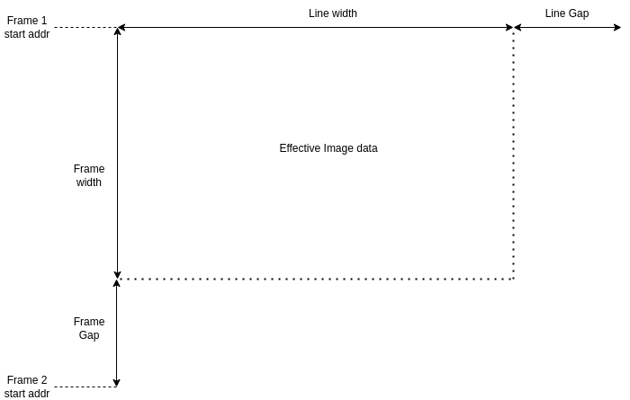

The total DDR4 memory is 24 GB, addressed using a 35-bit counter. This counter is split: the upper 9 bits select the frame number, and the lower 26 bits select the location within the frame. Each frame starts with a metadata line, followed by pixel data lines. Line addresses increase by a configurable step size (e.g., 12 KB). The lines are incremented by a given constant value. The Frame index is incremented on each frame valid signal assertion.

While using UDP data is provided in Row format without extra Line Gaps in the data
If PCIe is used with the start address and transfer size the transferred frame will include line gaps which needs to be processed on the receive side.

IMAGE METADATA
FARSIGHT’s metadata header is detailed in the table below:

Field | Size (bytes) | Type | Byte Address | Default Value(s) | Description
METADATA_START_FLAG | 4 |  | 0x00 | 0x4D45_5441 | Start flag
METADATA_SIZE_BYTES |  |  | 0x04 |  | Total metadata block size in bytes
SENSOR_PXL_READOUT_FORMAT | 4 | uint32_t | 0x08 |  | Sensor frame output format
SENSOR_READ_DIR | 4 | uint32_t | 0x0C |  | Sensor readout direction
SENSOR_BIT_DEPTH | 4 | uint32_t | 0x10 |  | Sensor image bit-depth
SENSOR_GAIN | 4 | uint32_t | 0x14 |  | Sensor gain dB (X10)
SENSOR_BLO | 4 | uint32_t | 0x18 |  | Sensor black level offset
SENSOR_EXPO_USEC | 4 | uint32_t | 0x1C |  | Exposure time in microseconds
SENSOR_TRIG_MODE | 4 | uint32_t | 0x20 |  | Image trigger mode configuration
SENSOR_TEMP_RAW | 4 | uint32_t | 0x24 |  | Raw sensor temperature reading
BUFF_WRITE_INDEX | 4 | uint32_t | 0x28 |  | DDR4 frame buffer write pointer index
FOCUS_REQ_DIST_M | 4 | uint32_t | 0x2C |  | Requested focus distance
FOCUS_COMP_DIST_M | 4 | uint32_t | 0x30 |  | Computed focus distance from LVDT
FOCUS_LVDT_POS_NM | 4 | int32_t | 0x34 |  | LVDT sensor position in nanometer
TIMESTAMP_UNIX_EPOCH_SEC | 4 | uint32_t | 0x38 |  | Unix epoch timestamp in seconds
TIMESTAMP_SUBSEC_NSEC | 4 | uint32_t | 0x3C |  | Sub-seconds timestamp in nanoseconds
VERSION | 4 | uint32_t (bitfield) | 0x40 |  | Subsystem version info
RESERVED PADDING |  |  | 0x44 |  | Reserved zero padding
RESERVED PADDING |  |  | 0x48 |  | Reserved zero padding
METADATA-CRC32 |  |  | 0x4C |  | CRC32 of Metadata calculated by FPGA during capture

Appendix A: FARSIGHT High-level Hardware Design

Fig Ref shows the high level architecture of FARSIGHT Payload system.

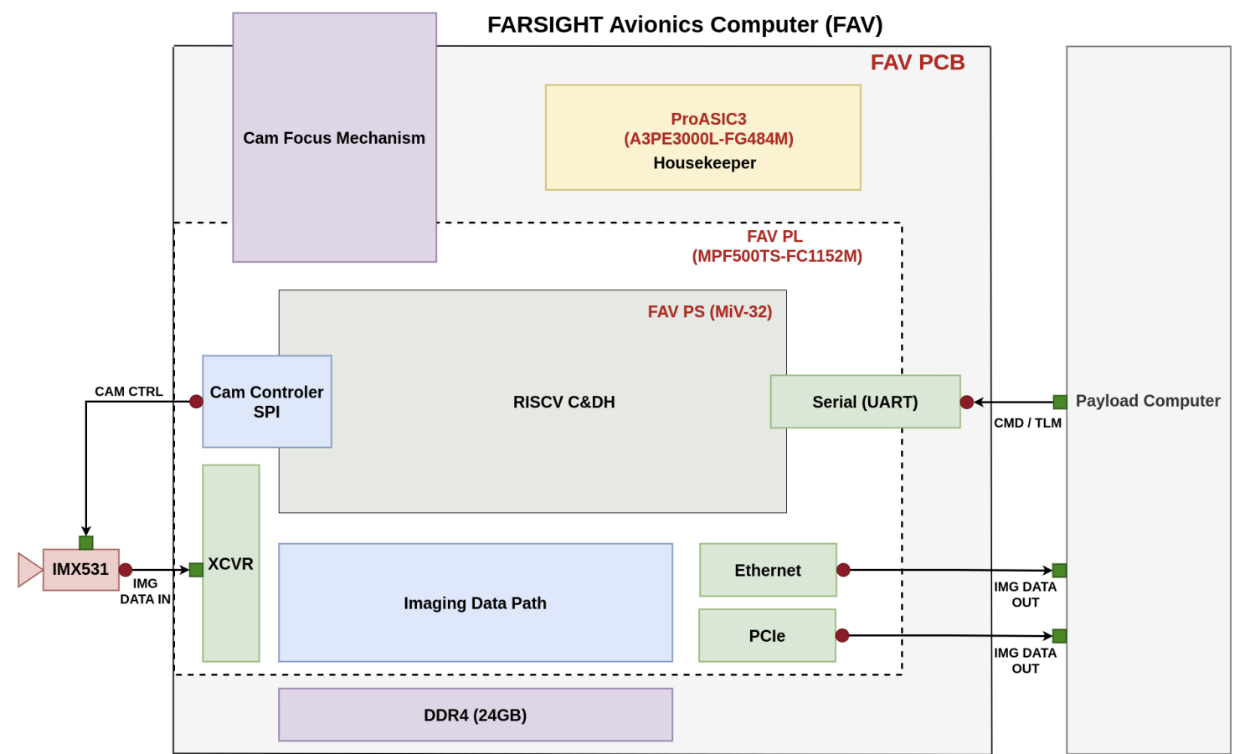
The FARSIGHT Avionics Computer (FAV) is the interface between the Payload Computer and the Camera Senor (IMX531). The FARSIGHT electronics reside on the FAV PCB which consists of two main FPGA chips and supporting components:
- ProASIC3 (A3PE3000L-FG484M) – Housekeeper FPGA: The housekeeper FPGA monitors power fluctuations and performs latchup protection in case of single-event latchup (SEL) issues caused by radiation
- PolarFIRE (MPF500TS-FC1152M) – FAV PL: The PolarFire FPGA serves as the main control interface and contains two primary subsystems
  - FAV PS (MiV-32): The Processing System hosts the RISC-V MiV-32 softcore processor which acts as the main Command and Data Handling (C&DH) unit. It is responsible for receiving and processing telecommands from the Payload Computer and responding with telemetry information.
  - Imaging Data Path: The programmable logic section handles high-speed image data processing and frame buffer management.

The main Telemetry and Telecommand (TMTC) interface between Farsight Avionics and the Payload Computer is a Serial UART interface backed by RS422 differential signaling for reliable CMD/TLM communication.

The Camera Sensor interface to the system consists of two main paths: the control path and the data path.
- Control Path (CAM CTRL): The Cam Controller uses a SPI interface that allows configuration of the IMX531 camera sensor via SPI protocol.
- Data Path (IMG DATA IN): The data path interface consists of 8-lane high-speed SERDES lanes running at 4752 Mbps/lane connected to the transceivers (XCVR) of the PolarFire FPGA. The image data passes through the Imaging Data Path pipeline and is stored in frame buffers allocated in the external 24GB DDR4 memory.

Additionally, the FAV includes a Camera Focus Mechanism for controlling the sensor position relative to the optical train.

For image data output (IMG DATA OUT), there are two main options to transfer data to the Payload Computer:
- Ethernet: The 1 Gigabit Ethernet interface supports up to 3 fps using User Datagram Protocol (UDP).
- PCIe: The PCIe endpoint interface support 5 Gbps data rate using PCIe Gen2.

Image Control Path:

Fig Ref shows the high-level view of the FARSIGHT Avionics imaging control path.
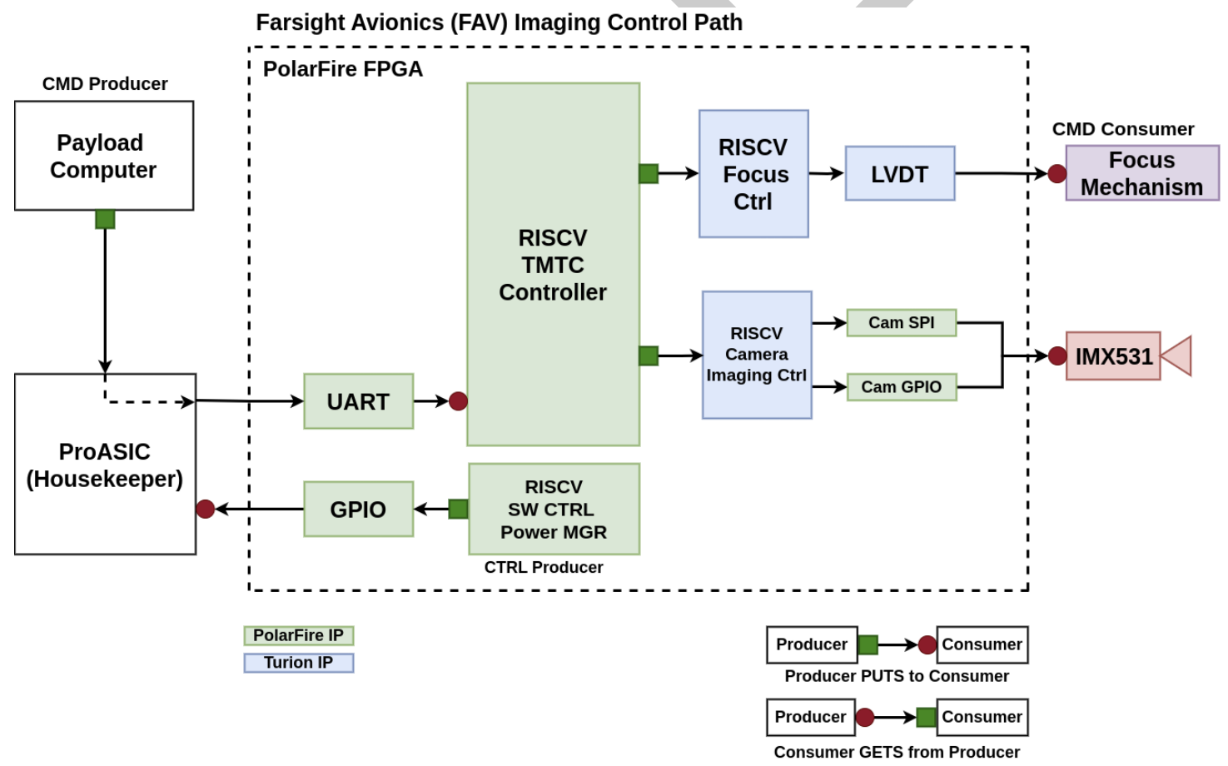

The Payload Computer sends telecommands to the FAV through a communication path that passes through the Housekeeper FPGA. Under nominal conditions, the Housekeeper FPGA operates as a pass-through for this communication link as long as the PolarFire FPGA is powered on. In the event that the PolarFire FPGA fails to power on, the Housekeeper FPGA assumes control of this path and transmits a beacon signal back to the Payload Computer indicating which power region has failed.

During nominal operation, telecommands from the Payload Computer are received by the RISC-V processor in the PolarFire FPGA via the serial port interface. The RISC-V firmware parses these commands and dispatches them to the appropriate target subsystem. The imaging control path consists of the following controllable subsystems:
- Camera Control Module: The camera control module consists of two main components
  - Camera SPI Interface: Provides configuration access to the IMX531 camera sensor registers via SPI protocol.
  - Trigger Module: Generates trigger pulses to initiate image capture based on user-specified exposure settings and frame rate (frames per second) parameters.
- Focus Mechanism Controller: Enables precise positioning of the camera focus mechanism through telecommands to achieve optimal image focus
- Housekeeper Interface Module: Provides the RISC-V firmware with the ability to monitor system status and issue commands to the Housekeeper FPGA for controlling various power regions within the system.

Imaging Data Path:

Fig Ref shows the high-level view of the FARSIGHT Avionics imaging data path.
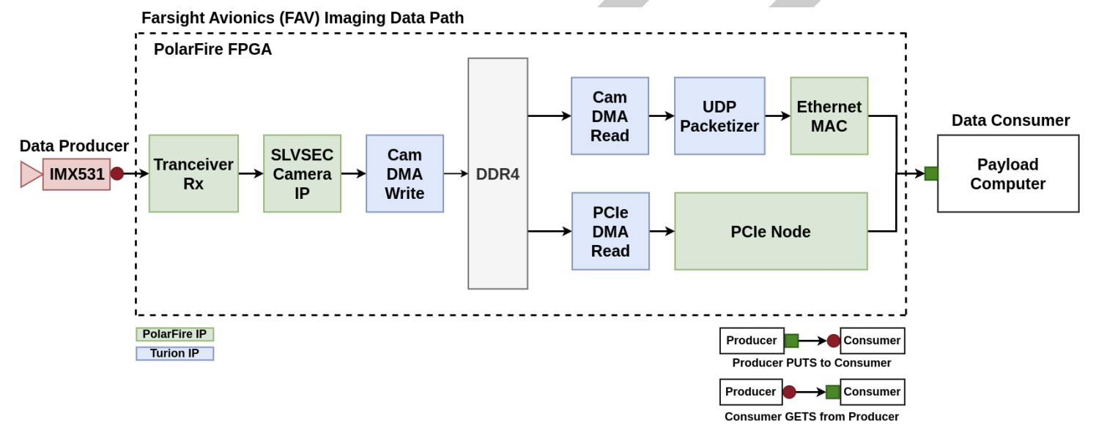
The imaging data path illustrates how image data flows from the IMX531 sensor to the Payload Computer. The IMX531 sensor acts as the data producer, transmitting image data through the Transceiver Rx block ito the SLVSEC Camera IP within the PolarFire FPGA. The Camera DMA write module then stores the incoming image frames into DDR4 memory.

From DDR4 memory, the system supports two parallel data paths to the Payload Computer (data consumer):
- Ethernet Path: The CAM DMA Read module retrieves image data from DDR4, which is then packetized by the UDP Packetizer and transmitted through the ethernet MAC to the Payload Computer.
- PCIe Path: The PCIe DMA Read module retrieves image data from the DDR4 and transfers it through the PCIe Node directly to the Payload Computer

Focus Mechanism:

Fig Ref shows the focus mechanism control system architecture.

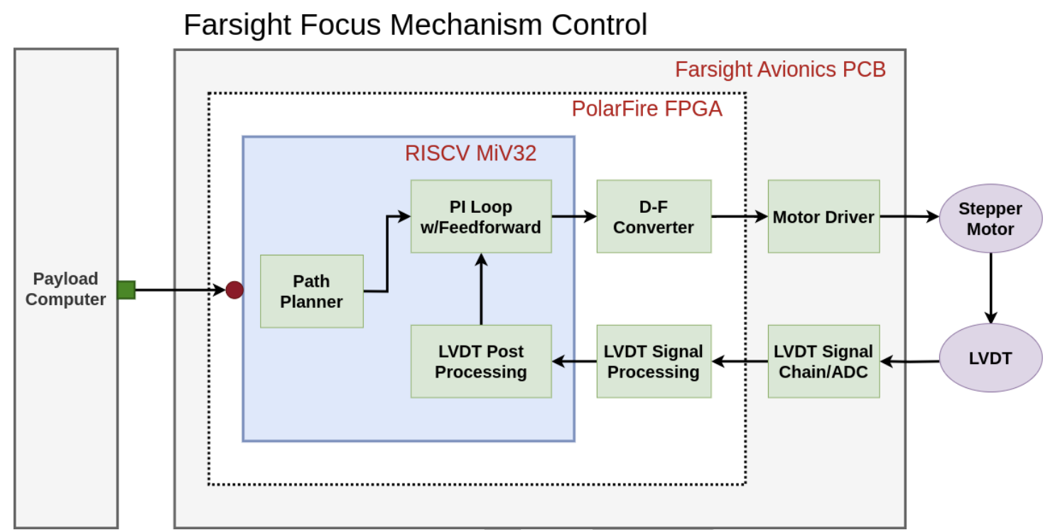

The focus mechanism control loop operates as follows: Upon receiving a focus command from the Payload Computer, the RISC-V MiV32 processor initiates path planning. If the commanded setpoint is too close to the current position, the Path Planner will first move the sensor away from the target before approaching the setpoint to avoid stiction issues.

The Path Planner generates updated velocity and position commands which are fed to the PI Loop with Feedforward. The PI loop employs velocity feedforward to improve motion profile tracking accuracy. Position feedback is provided by a Linear Variable Differential Transformer (LVDT) sensor, whose signal passes through the LVDT Signal Chain/ADC for analog-to-digital conversion, followed by LVDT Signal Processing and LVDT Post Processing blocks before being fed back to the PI loop.

The PI loop output is converted by the D-F Converter and sent to the Motor Driver, which commands the Stepper Motor to adjust the focus mechanism position. The motor is stopped once the desired position is reached, or if the position error exceeds a specified threshold in microns.

Hardware Power Protection:

FARSIGHT Avionics Housekeeper consists of two FPGA chips for managing and monitoring power status of the system. The ProASIC3 FPGA and PolarFire FPGA. The ProASIC3 FPGA Housekeeper is responsible for controlling and monitoring power to various subsystems on the Farsight Avionics board. It manages 33 power sources organized into 11 power regions, each with dedicated state machines for sequencing and fault detection. During normal operation, the ProASIC3 operates in pass-through mode, routing UART traffic directly between the PolarFire and the payload bus. If a critical failure occurs and the PolarFire is powered down, the ProASIC3 takes control of the UART and broadcasts a failure status message approximately once per second. The message format is shown in Table Ref.

